*Florida International University*

*School of Computing and Information Sciences*

CIS 4911 - Senior Capstone Project

Software Engineering Focus

Final Deliverable

Genomic Sequences

Team # 4

**Team Members**

Yordan Alvarez

Yohan Santos

**Product Owner**: Michael Robinson

**Instructor**: Masoud Sadjadi

**Copyright and trademark notices**

This is the work of Yordan Alvarez and Yohan Santos, unless specified otherwise.

Copyright © Florida International University 2015. All Rights Reserved. No part of the Genomic Sequences Project or documentation may be reproduced or modified without the express consent of Florida International University. Redistribution or commercial use is strictly prohibited.

***Abstract***

*The Final Deliverable of the Genomic Sequences project is meant to provide the reader with all the necessary development information regarding the system. The Genomic Sequences is a web application that helps health professionals, researchers, bioinformatics students, and anyone else with a desire to help to discover treatments for diseases. The web application provides to the users the possibility to quickly obtain a result file through email after uploading data to be analyzed. The tasks of the Genomic Sequences web application is to process data files provided by the users with algorithms that searches, analyzes, and compares the data files. Providing to the user with a summary about the differences, similarities, and analytics encountered on the data files. This will accelerate the process of obtaining a quick result needed during a medical or research examination. In addition, this document gives an introduction to the project, showcases the purpose of the new system, highlights the project plan created for completion of this application, determines the hardware and software requirements, provides details on the overall design of the application, and shows how we validated our application.*

**Table of Contents**

|  |  |
| --- | --- |
| **Content** | **Page(s)** |
| 1. Introduction | 6 |
| 1.1. Current System | 6 |
| 1.2. Purpose of New System | 7 |
| 2. User Stories | 8 |
| 2.1. Implemented User Stories | 8 |
| 2.2. Pending User Stories | 13 |
| 3. Project Plan | 14 |
| 3.1. Hardware and Software Resources | 14 |
| 3.2. Sprints Plan | 15 |
| 3.2.1. Sprint 1 | 15 |
| 3.2.2. Sprint 2 | 17 |
| 3.2.3. Sprint 3 | 19 |
| 3.2.4. Sprint 4 | 21 |
| 3.2.5. Sprint 5 | 23 |
| 4. System Design | 24 |
| 4.1. Architectural Patterns | 24 |
| 4.2. System and Subsystem Decomposition | 25 |
| 4.3. Deployment Diagram | 28 |
| 4.4. Design Patterns | 29 |
| 5. System Validation | 30 |
| 6. Glossary | 43 |
| 7. Appendix | 44 |
| 7.1. Appendix A - UML Diagrams | 44 |
| 7.1.1. Static UML Diagrams | 44 |
| 7.1.2. Dynamic UML Diagram | 52 |
| 7.2. Appendix B - User Interface Design | 63 |
| 7.3. Appendix C - Sprint Review Reports | 68 |
| 7.3.1. Sprint 1 Review | 68 |
| 7.3.2. Sprint 2 Review | 68 |
| 7.3.3. Sprint 3 Review | 69 |
| 7.3.4. Sprint 4 Review | 69 |
| 7.3.5. Sprint 5 Review | 70 |
| 7.4. Appendix D - Sprint Retrospective Reports | 71 |
| 7.4.1. Sprint 1 Retrospective | 71 |
| 7.4.2. Sprint 2 Retrospective | 71 |
| 7.4.3. Sprint 3 Retrospective | 72 |
| 7.4.4. Sprint 4 Retrospective | 72 |
| 7.4.5. Sprint 5 Retrospective | 73 |
| 7.5. Appendix E - Manuals | 74 |
| 7.5.1. User Manual | 74 |
| 7.5.2. Admin Manual | 86 |
| 8. References | 93 |

**Introduction**

This section aims to identify and describe both the structure of the system and how it will be created and designed within limited schedule. The purpose of the new system, user stories collected from the product owner to be implemented, as well as the user stories that were actually implemented within the time frame will be presented. In addition, our project plan designed to better clarify the vision of the system and how its different aspects will function together to form a complete solution. The section will also consider hardware and software system requirements, covered in detail, as well as the importance of the system design and how it will solve current problems within the domain. Lastly, the section will also describe the work breakdown performed during the five springs plans of development.

## Current System

Out of the 3.2 billion nucleotides in the human genome, over 95% is unknown. The recently completed five-year project named Encyclopedia of DNA Elements (ENCODE) concluded that about 80 percent of the human genome is active and it is not just junk DNA as it was previously called. If ENCODE was presented in graphical form, the data it has generated so far would fill a poster 30 kilometers long and 16 meters high. Meaning that there is a great amount of information and knowledge to be discovered from these results. Moreover, the current system in this modern age of genomics where vast quantities of information are generated but are associated with uncertainty in significance.

Biologists do not have the resources to identify computationally the portions of the genome that are significant to biologic disease processes and the information science experts do not have enough knowledge of these biologic processes to accurately model how to extract the relevant information. In addition, the current system is holding back many health professionals and researchers studying the area of bioinformatics as they encounter the problem of obtaining a fast and accurate result while processing Gigabytes of genomic data. The reason of this problem is that there is not currently an automated system that can accelerate this process and produce a proper result. In addition, the current system for processing genomic sequences is being done manually and this process could take days and even weeks to obtain an accurate result that can be error free.

## 

## 

## Purpose of New System

The purpose of the new system is to create a web application that will be able to automate and accelerate the task of processing Gigabytes of genomic sequences data files. The new system will offer to the users to efficiently process genomic data files and create one result document, which will contain accurate information about the differences, similarities, and analytics between the corresponding input files. In addition, the resulted document will be emailed to the users once the system is done processing the input files. In addition, the new system will allow the users to create and manage their account in which they can keep track of a history of documents submitted by them and results processed by the system. The new system will also eliminate the need to manually perform these data calculations done by users, which can considerably reduce the amount of errors the users can have while doing it manually. Additionally, the new system will provide to the users with speed, performance and accuracy to make their research advance in a faster peace.

**User Stories**

This section aims to identify a tentative comprehensive list of all user stories collected during the requirement analysis of the system with the product owner. It is good to mention that some of these user stories may not be implemented during this semester due to the time constraints. In addition, this section provides a list of those user stories that were implemented in this version of the system, and also a list of those user stories that will be classified as pending and carried over in a future version of this system.

## Implemented User Stories

**User Story # 89 - Login**

### Description:

* As a user I want to login into the system so that I can see my profile.

**Priority: Required**

**User Story # 90 - Logout**

### Description:

* As a user I want to logout of the system so that I can login into another account

**Priority: Required**

**User Story # 111 - Create Forgot Password**

### Description:

* As a user I want to be able to retrieve my password in case I forget it so that I can login into the system

**Priority: Required**

**User Story # 109 - Create User Registration**

**Description:**

* As a user I want to register to the system so that I can have a profile

**Priority: Required**

**User Story # 107 - Create User Profile**

**Description:**

* As a user I want to be able to view my profile so that I can manage my profile

**Priority: Required**

**User Story # 113 - Create Process Data**

**Description:**

* As a user I want to be able to process the data files I uploaded to the system so that I can receive the results of that processed data through email.

**Priority: Required**

**User Story # 114 - Create Contact Us Page**

**Description:**

* As a user I want to be able to contact the administrator of the web application, so that I can comment or suggest changes regarding the application.

**Priority: Required**

**User Story # 115 - Create Admin Profile**

**Description:**

* As an admin I want to be able to see my profile so that I can manage my profile.

**Priority: Required**

**User Story # 116 - Create Files Upload Page**

**Description:**

* As a user I want to be able to view my file upload page so that I can be able to upload files to the system

**Priority: Required**

**User Story # 110 - Create Document History Page**

**Description:**

* As a user I want to be able to see my document history page so that I can keep track of my documents

**Priority: Required**

**User Story # 112 - Create Analyze Data Types**

**Description:**

* As a user I want to be able to know which type of data are in my files have so that I can know if they are DNA, RNA, or Protein types.

**Priority: Required**

**User Story # 157 - Create User Photo Upload**

**Description:**

* As a user I want to be able to upload a profile picture so that I can personalized my user profile

**Priority: Required**

**User Story # 158 - Create User Change Password**

**Description:**

* As a user I want to be able to change my password so that I can choose a new password

**Priority: Required**

**User Story # 159 - Create Find Repeated Sequences On File**

**Description:**

* As a user, I want to be able to see which genomic repeated sequences are contained on my files so that I can know those repeated genomic sequences for my research

**Priority: Required**

**User Story # 177 - Create Find Genomic Probes**

**Description:**

* As a user I want to be able to find specific genomic sequences within files so that I can know which of these sequences are present on the files

**Priority: Required**

**User Story # 178 - Download Files from History**

**Description:**

* As a user I want to be able to download files from the history files page so that I can view the content and use those files for research.

**Priority: Required**

**User Story # 179 - Find Location of Repeated Sequences**

**Description:**

* As a user I want to be able to find the location of repeated sequences in a file and the distance between each location so that I can do analytics of the data

**Priority: Required**

**User Story # 180 - Create Visual Graph of Repeated Sequences**

**Description:**

* As a user I want to be able to see a graphical representation of a repeated genomic sequence file so that I can find data patterns in the file.

**Priority: Required**

**User Story # 199 - Create Find Differences Among Files**

**Description:**

* As a user I want to be able to find which genome sequences are present in one file that are not present in another file and vice versa, so that I can track that information for my research.

**Priority: Required**

**User Story # 201 - Create Admin Management Page**

**Description:**

* As an admin I want to be able to manage all users so that I can delete and modify the user.

**Priority: Required**

## Pending User Stories

There are not pending user stories during development of Genome Pro version 0.

# 

# 

# 

# 

# 

# 

# 

# 

# **Project Plan**

This section describes the project plan used to develop the system, which includes the hardware and software resources utilized in the software development process. Also, this section outlines the organization and work breakdown performed during each one of the five sprints. In addition, each sprint illustrates the user stories that were worked on with their respective description and acceptance criteria taken into account on each sprint.

Hardware and Software Resources

**Hardware:**

**●** PC - Windows OS (7 or 8), Mac (OS X or higher), and Linux (Ubuntu)

**Software:**

**● Mingle** (Software development management tool, required by instructor)

**● GitHub** (Software development source control tool, required by instructor)

**● Google Drive** (Cloud storage service tool, required by instructor)

**● PostGreSQL** (Open source Object-Relational database system, required by owner)

**● PHP** (Open source general-purpose scripting language, required by owner)

**● C** (Powerful system programming language, required by owner)

**● HTML** (Standardized system for tagging text on the Web, required by owner)

**● CSS** (Defines how HTML elements are to be displayed on the Web, required by owner)

**● Java** (Object Oriented Programming language, required by owner)

**● JavaScript** (Object-Oriented programming language that creates interactive effects

within web browsers, required by owner)

**● AngularJS** (Structural Framework for Dynamics Web Apps, lets you use HTML as your

template to express your application’s components clearly and succinctly)

**● Bootstrap** (HTML, CSS, and JS framework for developing responsive mobile web apps,

lets you speed up the front-end process and mobile friendly website designs)

**● MAMP** (Local hosting server application, supports Mac OS X and Windows)

**● StarUML** (Open source Software-Modeling tool, provides 11 types of UML diagrams)

**● LucidChart** (Web-based diagramming tool, provides collaborative UML diagrams)

**● NetBeans IDE** (Software development platform, allows applications to be developed

from a set of modular software components)

**● phpPgAdmin** (Web Application for managing PostgreSQL databases, UI for

PostgreSQL)

**● Skype** (Telecommunications application software, for development team

communication)

## 

## Sprints Plan

### Sprint 1

(05/18/2015 - 05/29/2015)

**User Story # 89 - Login**

***Tasks***

· Create Login template

· Design database schema

· Research PHP

· Testing Login

. Refine the final document

***Acceptance Criteria***

· Login needs to be part of the main page of the web application

· Once the user logs in, the system will not ask him/her to login again unless the user decides to log out.

**User Story # 90 - Log out**

***Tasks***

· Research PHP

· Testing Log out

. Refine the final document

***Acceptance Criteria***

· When the user logs out, the system will clear user information and display the main page

· User would be able to login again if wanted

**User Story # 111 - Create Forgot Password**

***Tasks***

· Create forgot password window

· Research PHP

· Testing forgot password

. Refine the final document

***Acceptance Criteria***

· Forgot password needs to be part of the main page of the web application

· Once the user clicks on forgot password the system will send an email to the user with his/her credentials to login into the system

**User Story # 109 - Create User Registration**

***Tasks***

· Design database schema

· Testing User Registration

. Refine the final document

***Acceptance Criteria***

1. User is able to see registration page after clicking on register in main page
2. User is able to enter his/her information into a text box
3. User is able to click on register button

**User Story # 107 - Create User Profile**

***Tasks***

· Design database schema

· Testing user profile

. Refine the final document

***Acceptance Criteria***

1. User is able to view his/her profile after login
2. User is able to see his/her general information after login or register

***Modeling***

Please see Appendix A Static UML Diagrams Figure #’s: 4, 5, 6, 7, 8

Please see Appendix A Dynamic UML Diagrams Figure #’s: 25, 26, 27, 28, 29

### 

### 

### Sprint 2

(06/01/2015 - 06/12/2015)

**User Story # 113 - Create Process Data**

***Tasks***

· Research about C and PHP Integration

· Create C program to process data files

. Refine the final document

. Research PHP

. Testing C program to process uploaded files

***Acceptance Criteria***

· When the user clicks on process data, the system will process the uploaded files

· The system will send an email to the user with the result file

. The user is able to receive the email and see the attached result file

**User Story # 114 - Create Contact Us Page**

***Tasks***

· Create Doc_Uploaded table in the database

· Create contact us template

. Refine the final document

. Research PHP

. Testing contact us

***Acceptance Criteria***

· Contact us needs to be part of the main page of the web application

· Once the user clicks on contact us, the system will redirect the user to another webpage in which contact us template will be presented to the user

. The user should be able to enter his/her information, and click on the send button

. The system should send an email to the administrator with the user’s comments or suggestions

**User Story # 115 - Create Admin Profile**

***Tasks***

· Research about Integrations

· Design Sketch

. Refine the final document

. Testing admin profile

***Acceptance Criteria***

· Admin is able to view his/her own profile after login

· Admin is able to see his/her general information after login

**User Story # 116 - Create Files Uploads Page**

***Tasks***

· Research about Integrations

· Design Sketch

. Refine the final document

. Testing user profiles uploads

***Acceptance Criteria***

· User is able view his/her file upload page

· User is able to view files upload buttons and process data button

. User is able to upload files to the system

***Modeling***

Please see Appendix A Static UML Diagrams Figure #’s: 9, 10, 11, 12

Please see Appendix A Dynamic UML Diagrams Figure #’s: 30, 31, 32, 33

### 

### 

### 

### 

### 

### Sprint 3

(06/15/2015 - 06/26/2015)

**User Story # 110 - Create Document History Page**

***Tasks***

· Page Template

· Test Document History Page

. Refine the final document

***Acceptance Criteria***

· User is able to view her/his document history page after clicking on history page

· User is able to view his/her uploaded files

. User is able to view his/her result files

. User is able to view files status

**User Story # 112 - Create Analyze Data Types**

***Tasks***

· Create panel and buttons functionalities

· Create C program to analyze data

. Create C program to validate data

. Test analyze data

. Refine the final document

***Acceptance Criteria***

· User is able to upload two data files to the system.

· User is able to click on Analyze data

. User is able to receive an email with the results of the type of data analyzed

**User Story # 157 - Create User Photo Upload**

***Tasks***

· Create upload photo functionality

· Test photo upload

. Refine the final document

***Acceptance Criteria***

· User is able to upload his/her profile picture

· User is able to change his/her profile picture

. User is able to see his/her profile picture once is uploaded

**User Story # 158 - Create User Change Password**

***Tasks***

· Create change password functionality

· Test change password

. Refine the final document

***Acceptance Criteria***

· User is able to change his/her password

· User is able to log in into the system after changing his/her password

**User Story # 159 - Create Find Repeated Sequences on File**

***Tasks***

· Test algorithm

· Create algorithm to find repeated sequences

. Refine the final document

***Acceptance Criteria***

· User is able to see a summary table of the genomic repeated sequences contained in the files

· User is able to receive an email with the summary table

***Modeling***

Please see Appendix A Static UML Diagrams Figure #’s: 13, 14, 15, 16, 17

Please see Appendix A Dynamic UML Diagrams Figure #’s: 34, 35, 36, 37, 38

### 

### Sprint 4

(06/29/2015 - 07/10/2015)

**User Story # 177 - Create Find Genomic Probes**

***Tasks***

· Create data validation

· Create C program to find genomic probes

. Refine the final document

. Design algorithm to find probes

. Test find genomic probes

***Acceptance Criteria***

· User is able to upload files and bash file

· User is able to receive an email with the results of the specific sequences contained in the files

**User Story # 178 - Download Files from History**

***Tasks***

· Create functionality to download files

. Refine the final document

. Research PHP

. Test download files from history

***Acceptance Criteria***

· User is able to click on the download link

· User is able to download the files successfully to his/her computer

**User Story # 179 - Find Location of Repeated Sequences**

***Tasks***

· Integration with graphs/charts

· Create algorithm to find locations

. Refine the final document

. Test algorithm

***Acceptance Criteria***

· User is able to view the location of the repeated sequences

· User is able to view the distances between the locations

**User Story # 180 - Create Visual Graph of Repeated Sequences**

***Tasks***

· Integration of graphs/charts

· Research on graphs/charts

. Refine the final document

***Acceptance Criteria***

· User is able to view the repeated sequences graphically

***Modeling***

Please see Appendix A Static UML Diagrams Figure #’s: 18, 19, 20, 21

Please see Appendix A Dynamic UML Diagrams Figure #’s: 39, 40, 41, 42

### 

### Sprint 5

(07/13/2015 - 07/24/2015)

**User Story # 199 - Create Find Differences Among Files**

***Tasks***

· Create data validation

· Design algorithm to find differences

. Create C program to find differences

. Refine the final document

. Test find differences

***Acceptance Criteria***

· User is able to upload two genome sequences files

. User is able to receive an email with the results

. User is able to see the result in an attachment result file

**User Story # 201 - Create Admin Management Page**

***Tasks***

· User type function

· Delete user function

. Design Interface

. DB integration

. Create management page

***Acceptance Criteria***

· Admin is able to see all users registered in the system

. Admin is able to delete users from the system

. Admin is able to change users Type

***Modeling***

Please see Appendix A Static UML Diagrams Figure #’s: 22, 23

Please see Appendix A Dynamic UML Diagrams Figure #’s: 43, 44

# 

# 

# **System Design**

This section will describe in detail the system architectures for the Genomic Sequences Web Application. It will provide an overview of the primary and the secondary architectural patterns to be used in the development of the application. In addition, it will provide a detailed subsystem decomposition description for each of the major subsystems. Also, the hardware and software mapping are defined, to show what the system will need to perform to satisfy the operations required by the users.

Architectural Patterns

As a result of our understanding of the system, we determined to use a 3-Tier architecture and Model View Controller (MVC) design to develop the Genomic Sequences application. The reasons for using (3-Tier) are because each tier part can be developed concurrently by different teams of programmers, coding in different languages from the other tier developers. In addition, the programming for a tier can be changed or relocated without affecting the other tiers. The (3-Tier) architecture makes it easier to continually evolve an application as new requirements and user stories arise. Consequently, using (3-Tier) architecture has a low level of difficulty for implementation, works well with (MVC), and allows changes to be made on the back-end to have little effect on the front-end side as long as the proper results are still sent to the front-end.

System and Subsystem Decomposition

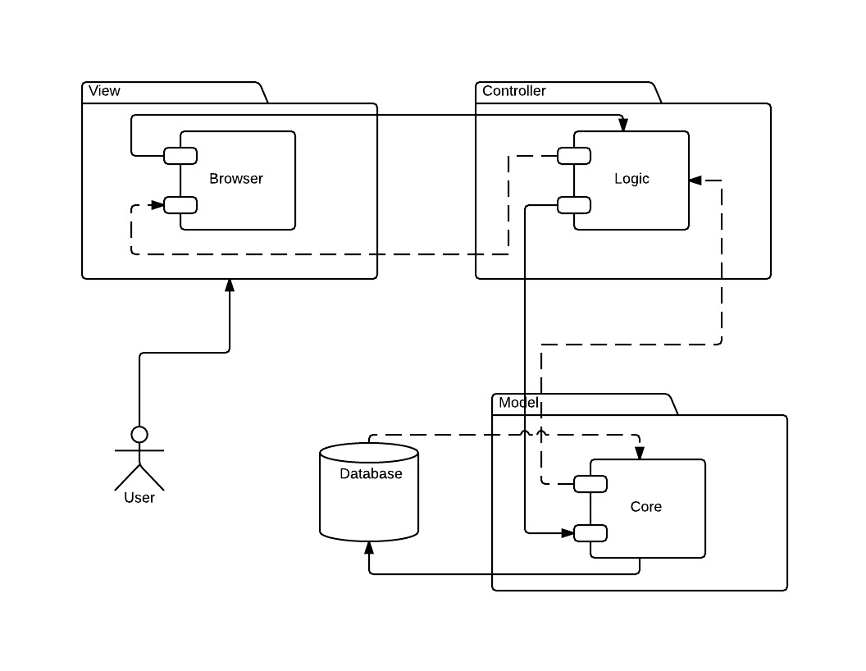

*Figure 1 - System Design (MVC)*

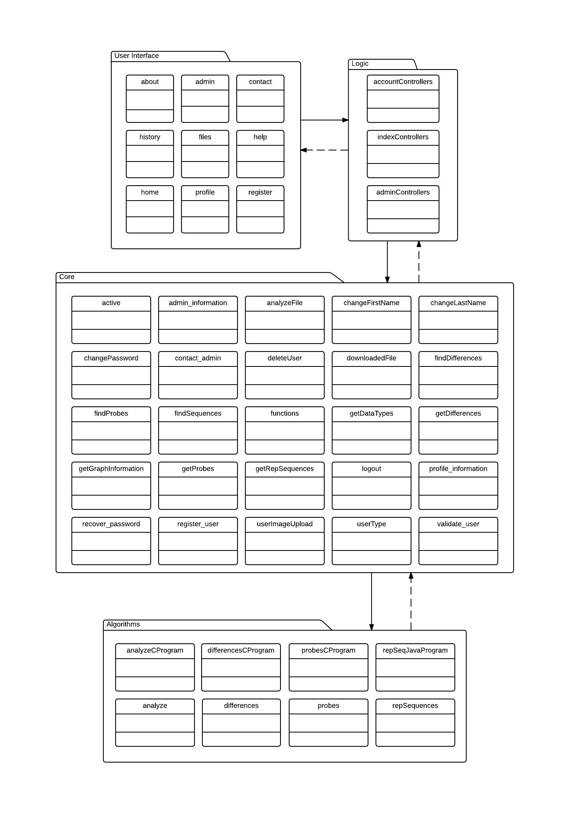

*Figure 2 - Sub-System Decomposition*

* User Interface Subsystem

The user interface subsystem plays the role of interacting with the user and

allowing the user to interact with the system. In addition, the user interface

subsystem retrieves all input from the user such as registration, login, data files,

contact us, recover password, and so on. The user interface subsystem also

allows the user to view their submitted files history and graphical representation

of some of the results processed by the system.

* Logic Subsystem

The logic subsystem is in charge of user input data handling and manipulation

as well as presenting to the user any system errors or messages that may occur.

Also, the logic subsystem works alongside the user interface subsystem and

core subsystem to provide to the user with the information that they requested

utilizing the user interface.

* Core Subsystem

The core subsystem is in charge of validating the data received from the logic

subsystem. Also, it is responsible for inserting, updating, and retrieving user

information from the data storage. The core subsystem additionally, plays the

role of performing all user actions that are occurring in the user interface side

such as recovering a password, uploading files to be analyzed, and so on.

The core subsystem also, serves as a bridge to pass the necessary data to the

algorithms subsystem, where all the user data processing occurs.

* Algorithms Subsystem

The algorithms subsystem is the subsystem that contains the algorithms used

by the system to find, analyze, and process the data uploaded by the user.

In addition, the algorithms subsystem is the one in charge of sending emails

to the user with the results once a process is finished. The algorithms subsystem

works alongside the core subsystem to provide to the user the facility of keeping

use of the system while a process is taking place.

## 

## Deployment Diagram

## 

*Figure 3 - Deployment Diagram*

Design Patterns

As a result of our understanding of the system, we determined to use the Model View Controller (MVC) design pattern and (3-Tier) architecture to develop the Genomic Sequences application. The reasons for using (MVC) is that this design will benefit the team at the time of implementation, because we can effectively divide the work. Also, any change in one of the classes does not need a large alteration, if any, to other classes. In addition, the (MVC) design pattern splits the system into three main parts, each responsible for a specific role in the system. Additionally, using (MVC) has a low level of difficulty for implementation, works well with (3-Tier) architecture, and allows changes to be made on the back-end to have little effect on the front-end side as long as the proper results are still sent to the front-end.

**System Validation**

In the system validation chapter the team is performing software testing in order to verify that the completed software package functions according to the expectations defined by the software requirements/specifications are working properly. The overall objective is to find every software bug that exists, and to uncover situations that could negatively impact the customer, usability and/or maintainability. This way, we can assure quality in the product we create, and make sure the product is tailored towards the right audience looking for the right features. Also, since some mistakes within our system can be difficult to detect without the use of automated testing, unforeseen faults can be captured before long term effects harm

the reputation of the system.

**User Story # 107 - User Profile**

|  |  |
| --- | --- |
| Test ID | Create_User_Profile_SUNNY_01 |
| Purpose | To validate that the user can see his/her profile. |
| Pre-condition | The web application needs to be working properly.  Internet connection established.  Have an account created. |
| Inputs | Email.  Password.  Click Login. |
| Expected Output | The profile is shown to the user. |

|  |  |
| --- | --- |
| Test ID | Create_User_Profile_RAINY_01 |
| Purpose | To validate that the user does not exist in the database. |
| Pre-condition | The web application needs to be working properly.  Internet connection established.  User does not have an account created. |
| Inputs | No existent email.  No existen password.  Click Login. |
| Expected Output | An error message is shown to the user saying wrong email or password. |

**User Story # 109 - User Registration**

|  |  |
| --- | --- |
| Test ID | Create_User_Registration_SUNNY_01 |
| Purpose | To validate that the user can create an account. |
| Pre-condition | The web application needs to be working properly.  Internet connection established.  User does not have an account. |
| Inputs | First name.  Last name.  Email.  Password.  Confirmation password. |
| Expected Output | The account creation is shown to the user. |

|  |  |
| --- | --- |
| Test ID | Create_User_Registration_RAINY_01 |
| Purpose | To validate that the user enter wrong passwords. |
| Pre-condition | The web application needs to be working properly.  Internet connection established.  User does not have an account. |
| Inputs | First name.  Last name.  Email.  Password.  Confirmation password different. |
| Expected Output | A message saying passwords does not match.. |

**User Story # 89 - User Login**

|  |  |
| --- | --- |
| Test ID | Create_User_Login_SUNNY_01 |
| Purpose | To validate that the user can login into the system. |
| Pre-condition | The web application needs to be working properly.  Internet connection established.  User must have an account. |
| Inputs | User email.  Password.  Click login. |
| Expected Output | The user is redirected to the profile page. |

|  |  |
| --- | --- |
| Test ID | Create_User_Login_RAINY_01 |
| Purpose | To validate that the user cannot login into the system. |
| Pre-condition | The web application needs to be working properly.  Internet connection established.  User must have an account. |
| Inputs | User email.  Incorrect password.  Click login. |
| Expected Output | A message is shown saying email or password incorrect. |

**User Story # 90 - User Logout**

|  |  |
| --- | --- |
| Test ID | Create_User_Logout_SUNNY_01 |
| Purpose | To validate that the user can logout of the system. |
| Pre-condition | The web application needs to be working properly.  Internet connection established.  User have an account. |
| Inputs | Click logout. |
| Expected Output | The user is redirected to the home page |

**User Story # 111 - User Forgot Password**

|  |  |
| --- | --- |
| Test ID | Create_User_Forgot_Password_SUNNY_01 |
| Purpose | To validate that the user can recover his/her password. |
| Pre-condition | The web application needs to be working properly.  Internet connection established.  User have an account. |
| Inputs | User email.  Click recover password. |
| Expected Output | A new password is sent to the user through email. |

|  |  |
| --- | --- |
| Test ID | Create_User_Forgot_Password_RAINY_01 |
| Purpose | To validate that the user cannot recover his/her password if entered email does not exists in the data storage. |
| Pre-condition | The web application needs to be working properly.  Internet connection established.  User have an account. |
| Inputs | User “email” that does not exist in the data storage.  Click recover password. |
| Expected Output | A message saying wrong email. |

**User Story # 114 - User Contact**

|  |  |
| --- | --- |
| Test ID | Create_User_Contact_SUNNY_01 |
| Purpose | To validate that the user can contact the admin. |
| Pre-condition | The web application needs to be working properly.  Internet connection established. |
| Inputs | Name  Subject  Email.  Massage.  Click send message. |
| Expected Output | A message saying the information has been sent. |

|  |  |
| --- | --- |
| Test ID | Create_User_Contact_RAINY_01 |
| Purpose | To validate that the user cannot contact admin. |
| Pre-condition | The web application needs to be working properly.  Internet connection established. |
| Inputs | User leaves a field blank  Click send message. |
| Expected Output | A message saying to please fill the blank field. |

**User Story # 115 - Admin Profile**

|  |  |
| --- | --- |
| Test ID | Create_Admin_Profile_SUNNY_01 |
| Purpose | To validate that the admin can see his/her profile. |
| Pre-condition | The web application needs to be working properly.  Internet connection established.  Admin have an account. |
| Inputs | Username “email”.  Password.  Click login. |
| Expected Output | The admin profile is shown. |

|  |  |
| --- | --- |
| Test ID | Create_Admin_Profile_RAINY_01 |
| Purpose | To validate that the admin cannot see his/her profile. |
| Pre-condition | The web application need to be working properly.  Internet connection established.  Admin have an account. |
| Inputs | Admin enters an incorrect “email”.  Password.  Click login. |
| Expected Output | A message saying that username or password is incorrect. |

**User Story # 116 - User File Uploads Page**

|  |  |
| --- | --- |
| Test ID | Create_File_Uploads_Page_SUNNY_01 |
| Purpose | To validate that the user can upload files. |
| Pre-condition | The web application needs to be working properly.  Internet connection established. |
| Inputs | Upload files 1 and 2.  Click Process Data. |
| Expected Output | The files shown as upload and ready to be process. |

|  |  |
| --- | --- |
| Test ID | Create_File_Upload_Page_RAINY_01 |
| Purpose | To validate that the user cannot upload files. |
| Pre-condition | The web application needs to be working properly.  Internet connection established. |
| Inputs | Upload one file only.  Click Process Data. |
| Expected Output | A message saying that he/she needs to upload two files in order to be processed. |

**User Story # 110 - User Create Document History Page**

|  |  |
| --- | --- |
| Test ID | Create_Document_History_Page_SUNNY_01 |
| Purpose | To validate that the user can see her/his document history. |
| Pre-condition | The web application needs to be working properly.  Internet connection established.  The user needs to be login into the system |
| Inputs | Click history tab on the navigation bar |
| Expected Output | The files will show in the History page. |

|  |  |
| --- | --- |
| Test ID | Create_Document_History_Page_RAINY_01 |
| Purpose | To validate that the user cannot see her/his document in the history page. |
| Pre-condition | The web application needs to be working properly.  Internet connection established.  The user needs to be login into the system |
| Inputs | The user uploads a corrupted data file to the system. |
| Expected Output | The user will not be able to see his/her file in the History page because the system will reject the corrupt file. |

**User Story # 112 - User Analyze Genomic Data**

|  |  |
| --- | --- |
| Test ID | Analyze_Genomic_Data_SUNNY_01 |
| Purpose | To validate that the user can upload and analyze a genome file |
| Pre-condition | The web application needs to be working properly.  Internet connection established.  The user needs to be logged in |
| Inputs | User choose a genomic sequence file and clicks analyze |
| Expected Output | System will send an email to the user with the results |

|  |  |
| --- | --- |
| Test ID | Analyze_Genomic_Data_RAINY_01 |
| Purpose | To validate that the user cannot receive a result. |
| Pre-condition | The web application needs to be working properly.  Internet connection established.  The user needs to be logged in |
| Inputs | User uploads a genomic sequences file with wrong data and clicks analyze |
| Expected Output | A message saying that the data contained in the file is invalid |

**User Story # 157 - Create User Photo Upload**

|  |  |
| --- | --- |
| Test ID | Create_User_Photo_Upload_SUNNY_01 |
| Purpose | To validate that the user can upload a profile photo. |
| Pre-condition | The web application needs to be working properly.  Internet connection established.  The user needs to be logged in |
| Inputs | User selects and uploads a profile photo |
| Expected Output | System shows the photo in the user profile photo box |

|  |  |
| --- | --- |
| Test ID | Create_User_Photo_Upload_RAINY_01 |
| Purpose | To validate that the user cannot see his/her profile photo. |
| Pre-condition | The web application needs to be working properly.  Internet connection established.  The user needs to be logged in |
| Inputs | User exceeds the upload photo size. |
| Expected Output | The user will not be able to see their photo profile because the maximum size has been reached. |

**User Story # 158 - Create User Change Password**

|  |  |
| --- | --- |
| Test ID | Create_User_Change_Password_SUNNY_01 |
| Purpose | To validate that the user can change her/his password. |
| Pre-condition | The web application needs to be working properly.  Internet connection established.  The user needs to be logged in |
| Inputs | User enters his current password, new password and repeated new password then clicks on change password. |
| Expected Output | System shows to the user an alert box saying password have been changed successfully. |

|  |  |
| --- | --- |
| Test ID | Create_User_Change_Password_RAINY_01 |
| Purpose | To validate that the user cannot change her/his password. |
| Pre-condition | The web application needs to be working properly.  Internet connection established.  The user needs to be logged in |
| Inputs | User enters wrong current password , new password, and repeat new password and click on change password. |
| Expected Output | System shows to the user that an error has occurred changing the password because current password is incorrect. |

**User Story # 159 - Create Find Repeated Sequences on File**

|  |  |
| --- | --- |
| Test ID | Create_Find_Repeated_Sequences_on_File_SUNNY_01 |
| Purpose | To validate that the user can find repeated sequences on files. |
| Pre-condition | The web application needs to be working properly.  Internet connection established.  The user needs to be logged in |
| Inputs | User uploads a file to the system and clicks on find |
| Expected Output | System emails the user a summary of the repeated sequences in the file submitted. |

|  |  |
| --- | --- |
| Test ID | Create_Find_Repeated_Sequences_on_File_RAINY_01 |
| Purpose | To validate that the user cannot receive the repeated sequences summary. |
| Pre-condition | The web application needs to be working properly.  Internet connection established.  The user needs to be logged in |
| Inputs | User upload a corrupt file to the system and clicks find |
| Expected Output | System shown to the user that an error with the file occurred |

**User Story # 177 - Create Find Genomic Probes**

|  |  |
| --- | --- |
| Test ID | Create_Find_Genomic_Probes_SUNNY_01 |
| Purpose | To validate that the user can find genomic probes on files. |
| Pre-condition | The web application needs to be working properly.  Internet connection established.  The user needs to be logged in |
| Inputs | User uploads two files to the system and clicks on find |
| Expected Output | System emails the user a summary of the genomic probes founded in the files submitted. |

|  |  |
| --- | --- |
| Test ID | Create_Find_Genomic_Probes_RAINY_01 |
| Purpose | To validate that the user cannot receive the genomic probes summary. |
| Pre-condition | The web application needs to be working properly.  Internet connection established.  The user needs to be logged in |
| Inputs | User uploads files with invalid data to the system and clicks find |
| Expected Output | System shows to the user an error saying that the data in the files is invalid |

**User Story # 178 - Download Files from History**

|  |  |
| --- | --- |
| Test ID | Download_Files_from_History_SUNNY_01 |
| Purpose | To validate that the user can download files from the history. |
| Pre-condition | The web application needs to be working properly.  Internet connection established.  The user needs to be logged in |
| Inputs | User clicks on download icon |
| Expected Output | The user is able to download the files to his/her computer. |

|  |  |
| --- | --- |
| Test ID | Download_Files_from_History_RAINY_01 |
| Purpose | To validate that the user cannot download the files from the history. |
| Pre-condition | The web application needs to be working properly.  Internet connection established.  The user needs to be logged in |
| Inputs | User clicks on download a file that is in progress. |
| Expected Output | The user will not be able to download the file to his/her computer |

**User Story # 179 - Find Location of Repeated Sequences**

|  |  |
| --- | --- |
| Test ID | Find_Location_of_Repeated_Sequences_SUNNY_01 |
| Purpose | To validate that the user can find locations of repeated sequences on files. |
| Pre-condition | The web application needs to be working properly.  Internet connection established.  The user needs to be logged in |
| Inputs | User uploads a file to the system and clicks on find |
| Expected Output | System emails the user a summary of the location of the repeated sequences in the file submitted. |

|  |  |
| --- | --- |
| Test ID | Find_Location_ of_Repeated_Sequences_RAINY_01 |
| Purpose | To validate that the user cannot receive the location of repeated sequences summary. |
| Pre-condition | The web application needs to be working properly.  Internet connection established.  The user needs to be logged in |
| Inputs | User upload a corrupt files to the system and clicks find |
| Expected Output | System shows to the user an error saying that the data in the files is invalid |

**User Story # 180 - Create Visual Graph of Repeated Sequences**

|  |  |
| --- | --- |
| Test ID | Create_Visual_Graph_ of_Repeated_Sequences_SUNNY_01 |
| Purpose | To validate that the user can see a visual graph of the repeated sequences on files. |
| Pre-condition | The web application needs to be working properly.  Internet connection established.  The user needs to be logged in |
| Inputs | User clicks on graph. |
| Expected Output | System shows a box containing the graph with the repeated sequences. |

|  |  |
| --- | --- |
| Test ID | Create_Visual_Graph_ of_Repeated_Sequences_RAINY_01 |
| Purpose | To validate that the user cannot see a visual graph of the repeated sequences summary. |
| Pre-condition | The web application needs to be working properly.  Internet connection established.  The user needs to be logged in |
| Inputs | User clicks on graph icon while a file is still in progress |
| Expected Output | The user will not be able to see a graph until progress is done |

**User Story # 199 - Create Find Differences Among Files**

|  |  |
| --- | --- |
| Test ID | Create_Find_Differences_Among_Files_SUNNY_01 |
| Purpose | To validate that the user can find differences among files. |
| Pre-condition | The web application needs to be working properly.  Internet connection established.  The user needs to be logged in |
| Inputs | User uploads two genome files and clicks find. |
| Expected Output | System emails the user a summary of the differences founded in the files submitted. |

|  |  |
| --- | --- |
| Test ID | Create_Find_Differences_Among_Files_RAINY_01 |
| Purpose | To validate that the user cannot find differences among files. |
| Pre-condition | The web application needs to be working properly.  Internet connection established.  The user needs to be logged in |
| Inputs | User uploads one genome file and one corrupt file and then clicks find. |
| Expected Output | System shows to the user an error saying that the data in one of the files is invalid |

**User Story # 201 - Create Admin Management Page**

|  |  |
| --- | --- |
| Test ID | Create_Adminl_Management_Page_SUNNY_01 |
| Purpose | To validate that the admin is able to see all users registered in the system. |
| Pre-condition | The web application needs to be working properly.  Internet connection established.  The user needs to be logged in |
| Inputs | Admin clicks on Administration page tab. |
| Expected Output | System shows a list of all users on the system. |

|  |  |
| --- | --- |
| Test ID | Create_Adminl_Management_Page_RAINY_01 |
| Purpose | To validate that the admin is not able to see all user register in the system. |
| Pre-condition | The web application needs to be working properly.  Internet connection established.  The user needs to be logged in |
| Inputs | Admin clicks on Administration tab but the server is down or maintenances. |
| Expected Output | System shows to the admin that an error occurred with the users list. |

**Glossary**

|  |  |
| --- | --- |
| Term | Definition |
| Genomic Sequence | Is a laboratory process that determines the complete **DNA** **sequence** of an organism's **genome** at a single time. |
| DNA | Deoxyribonucleic acid is a molecule that encodes the genetic instructions used in the development and functioning of all known living organisms and many viruses. |
| Sequence | A set of related events, movements, or things that follow each other in a particular order. |
| Genome | The complete set of genes or genetic material present in a cell or organism. |
| User Story | Helps to create a simplified description of a requirement. |
| Nucleotides | Forms the basic structural unit of nucleic acids such as DNA. |
| Human Genome | Is the complete set of genetic information for humans (Homo sapiens). |
| Dynamic | Capable of action or change |
| Static | Stationary, fixed |

**Appendix**

## Appendix A - UML Diagrams

### Static UML Diagrams

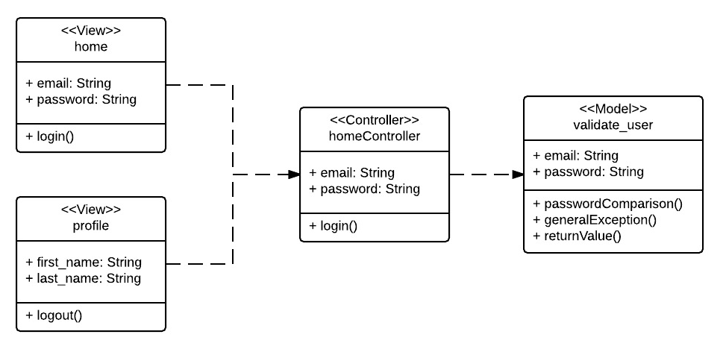

*Figure 4 - Login Class Diagram*

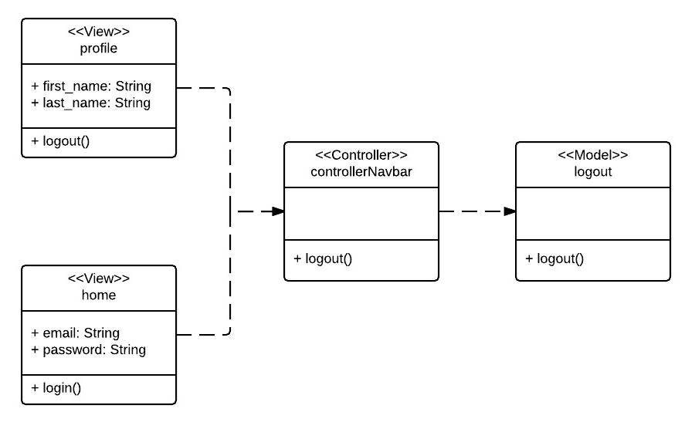

*Figure 5 - Log out Class Diagram*

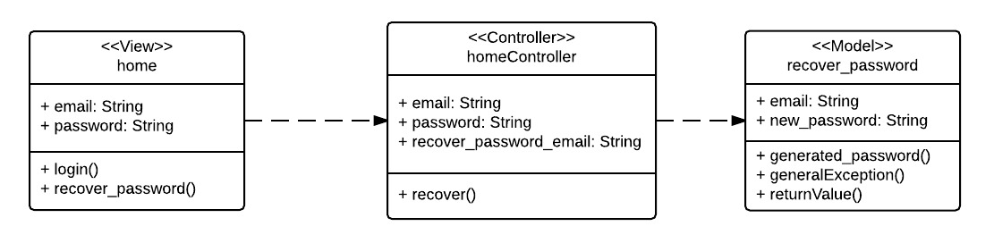

*Figure 6 - Forgot Password Class Diagram*

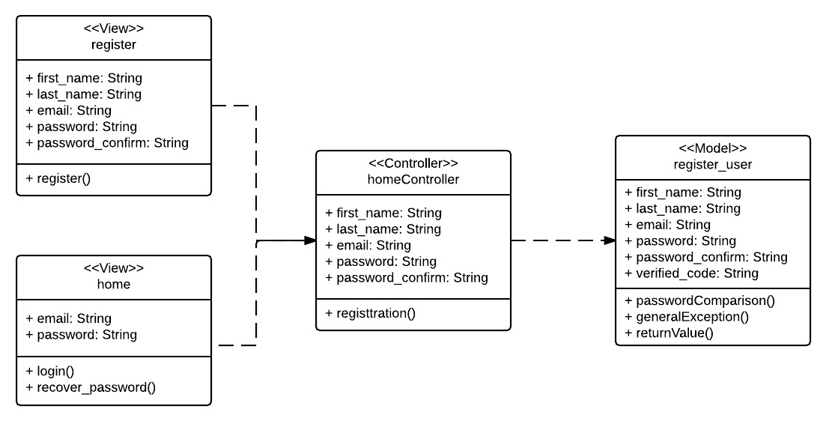

*Figure 7 - User Registration Class Diagram*

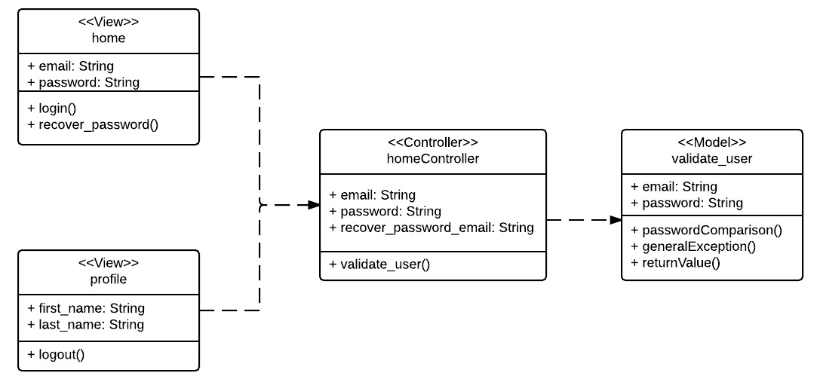

*Figure 8 - User Profile Class Diagram*

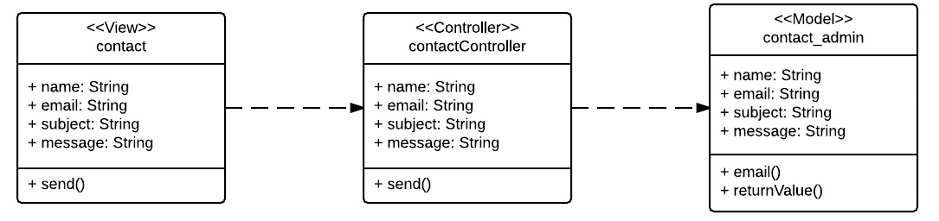

*Figure 9 - Contact Us Class Diagram*

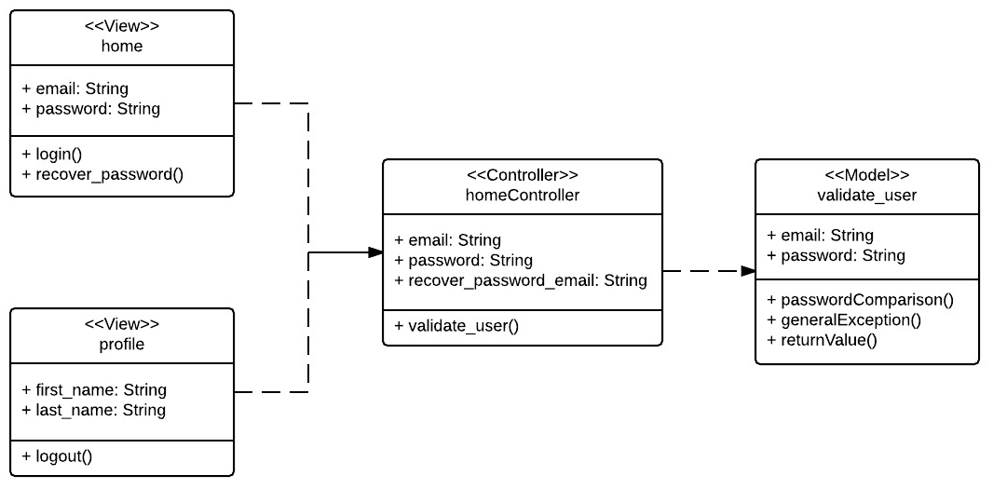

Figure 10 - Admin Profile Class Diagram

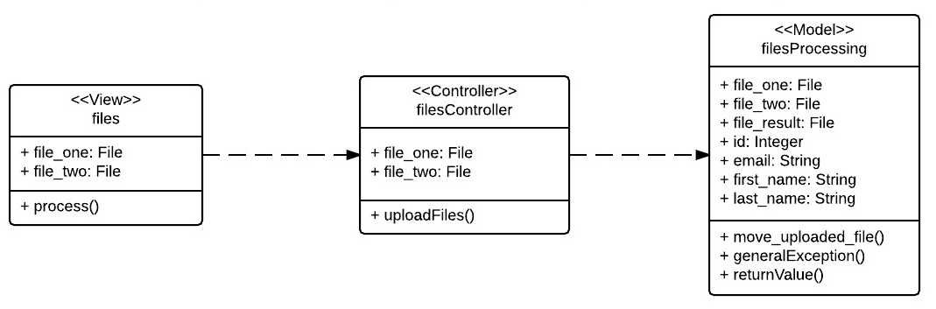

*Figure 11 - Files Upload Class Diagram*

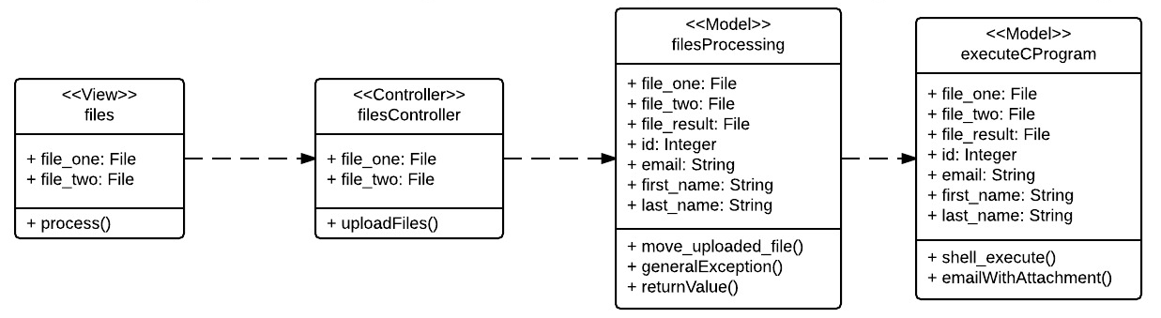

*Figure 12 - Process Data Class Diagram*

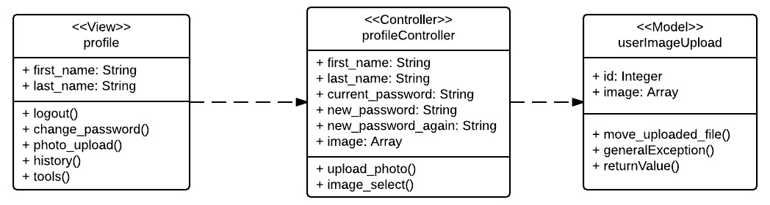

*Figure 13 - User Photo Upload Class Diagram*

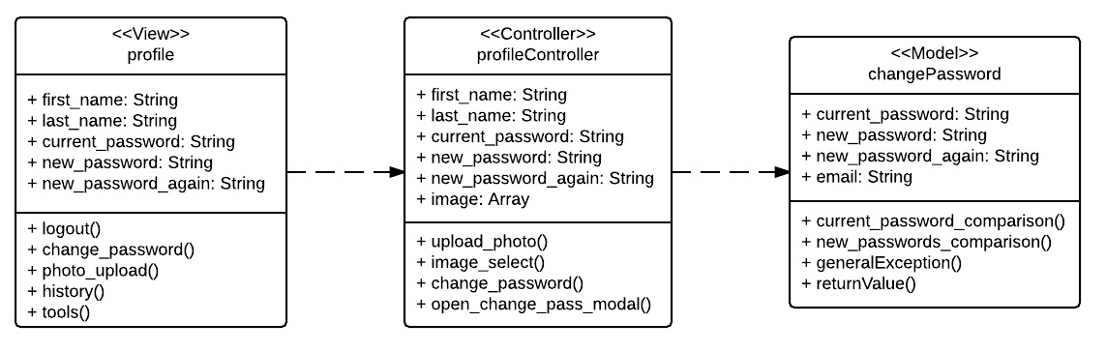

*Figure 14 - User Change Password Class Diagram*

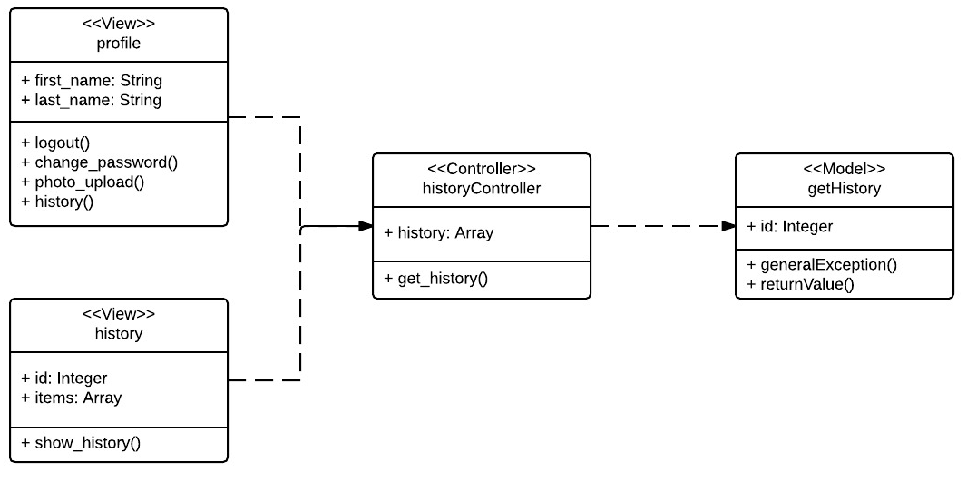

*Figure 15 - Document History Class Diagram*

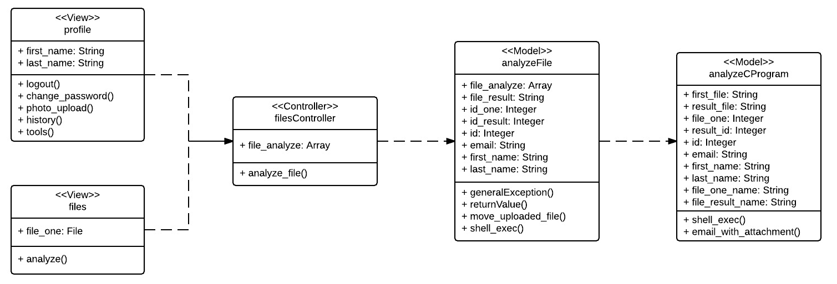

*Figure 16 - Analyze Data Types Class Diagram*

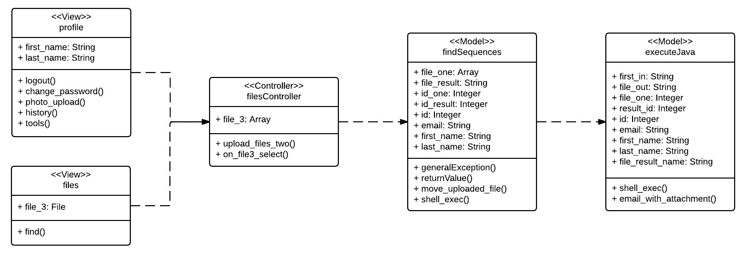

*Figure 17 - Find Repeated Sequences Class Diagram*

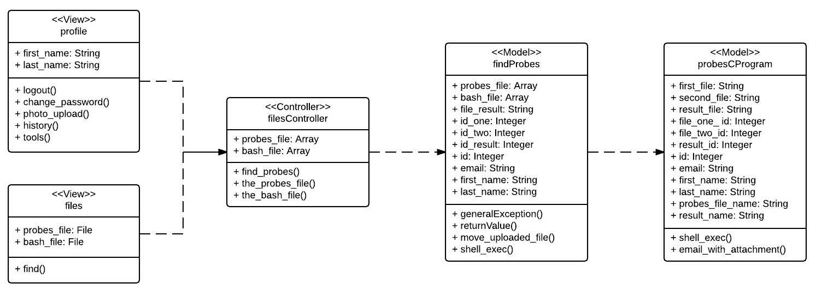

*Figure 18 - Find Genomic Probes Class Diagram*

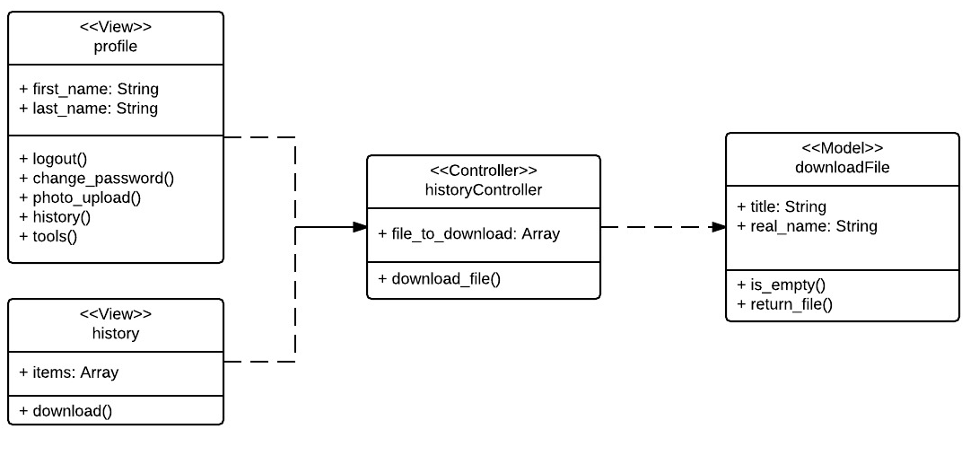

*Figure 19 - Download Files from History Class Diagram*

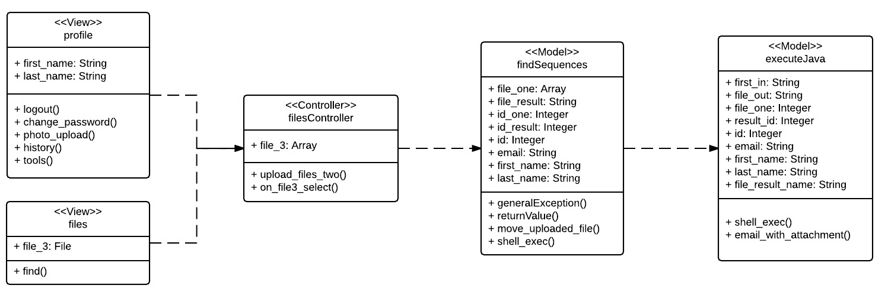

*Figure 20 - Find Location, Distances Class Diagram*

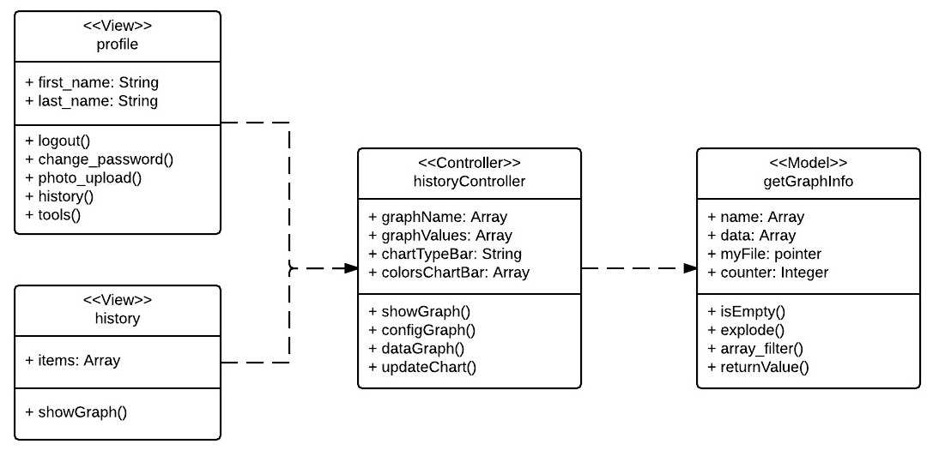

*Figure 21 - Visual Graph of Repeated Class Diagram*

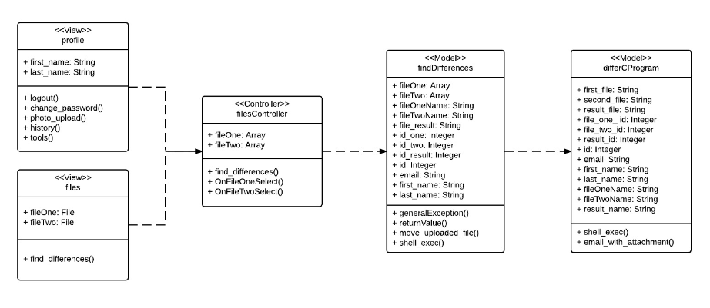

*Figure 22 - Find Differences Among Files Class Diagram*

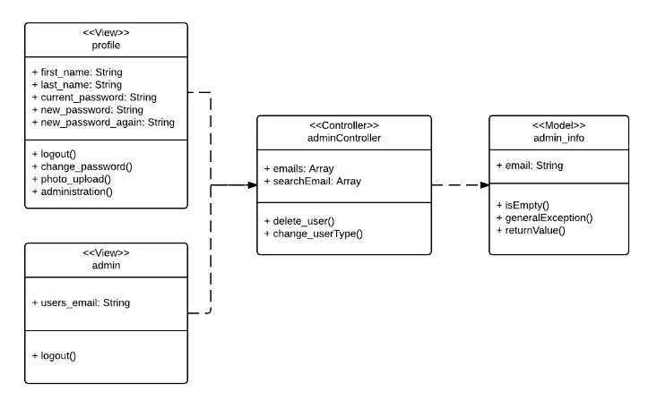

*Figure 23 -Admin Management Page Class Diagram*

### 

### 

### 

### 

### 

### 

### 

### 

### 

### 

### 

### Dynamic UML Diagrams

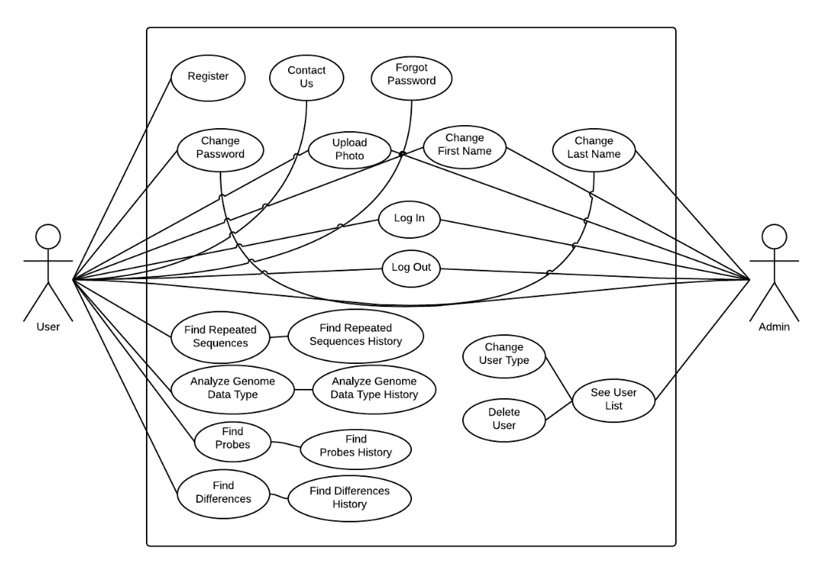

*Figure 24 - Use Cases Diagram*

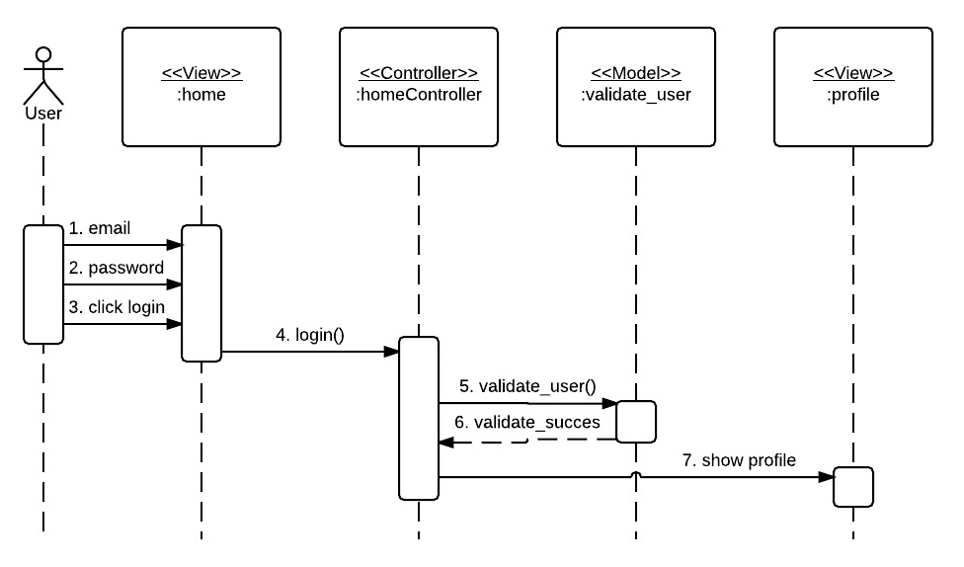

Figure 25 - Login Sequence Diagram

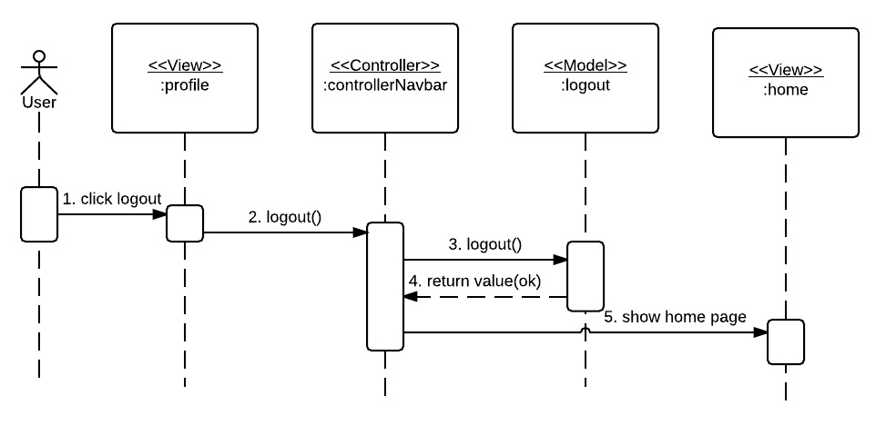

*Figure 26 - Log out Sequence Diagram*

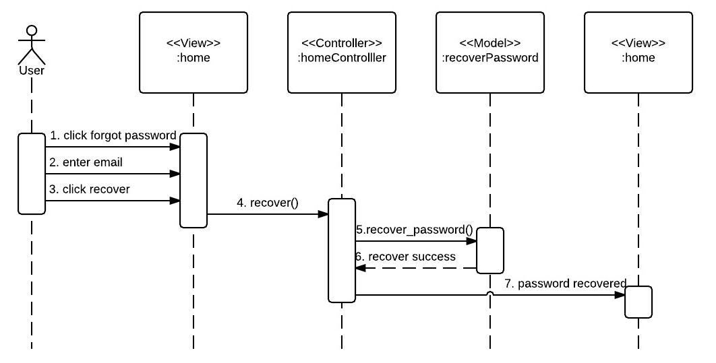

Figure 27 - Create Forgot Password Sequence Diagram

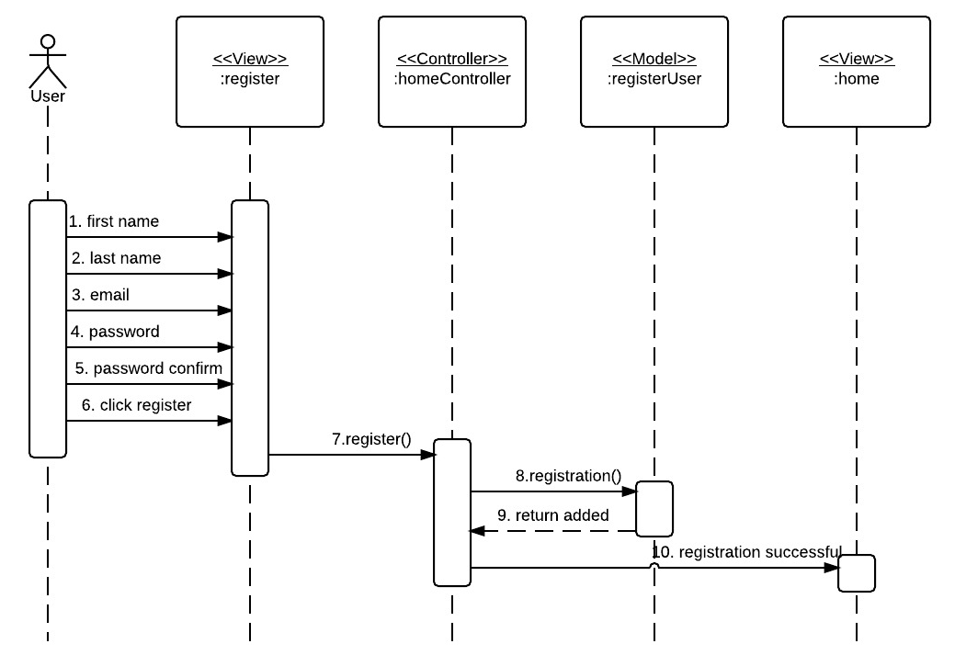

*Figure 28 - Create User Registration Sequence Diagram*

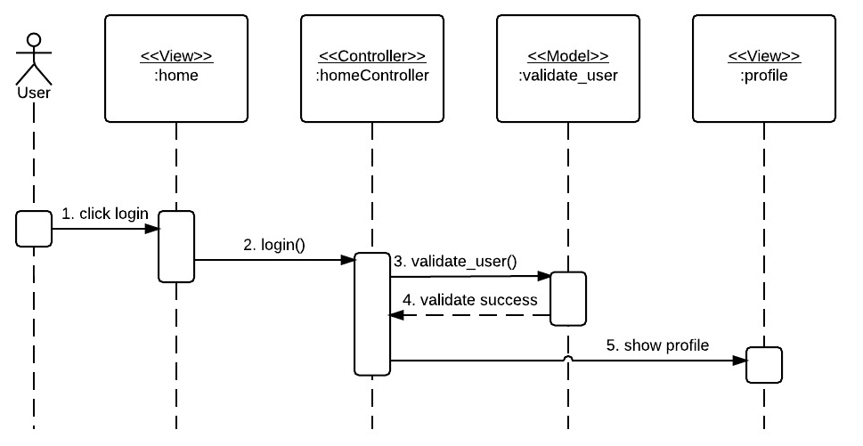

Figure 29 - Create User Profile Sequence Diagram

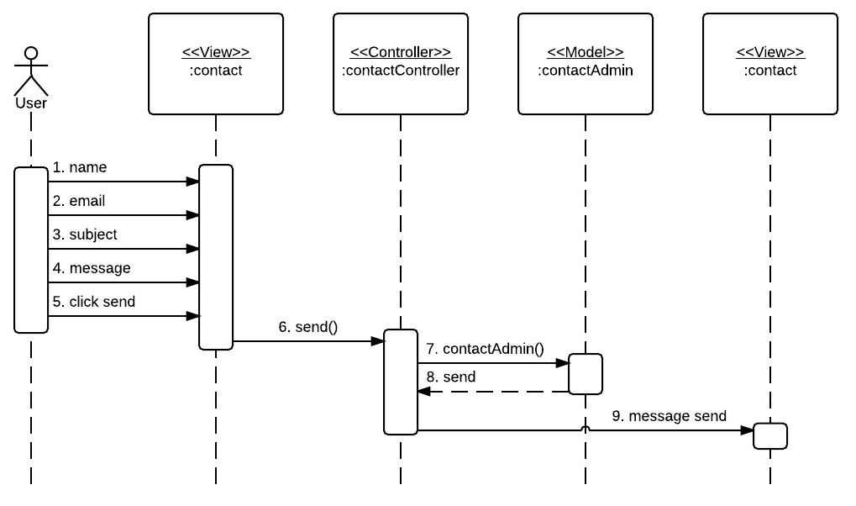

*Figure 30 - Create Contact Us Page Sequence Diagram*

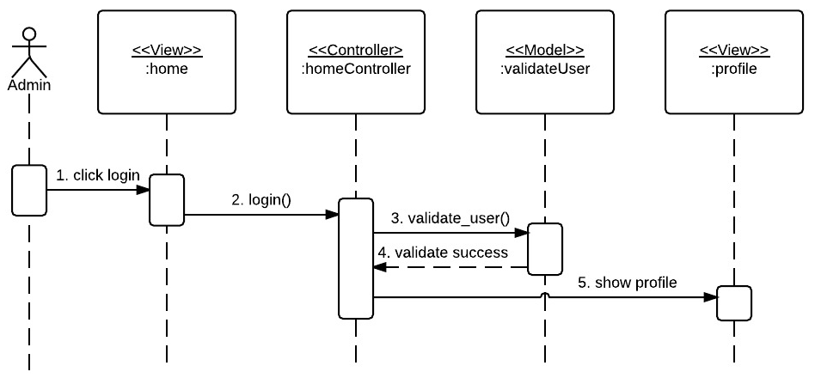

Figure 31 - Admin Profile Sequence Diagram

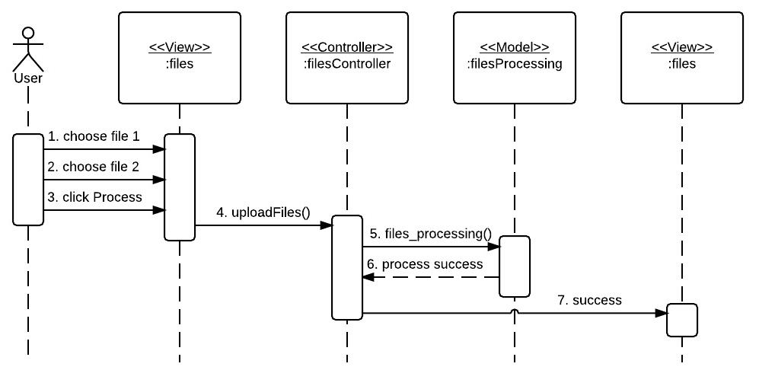

*Figure 32 - Create Files Upload Page Sequence Diagram*

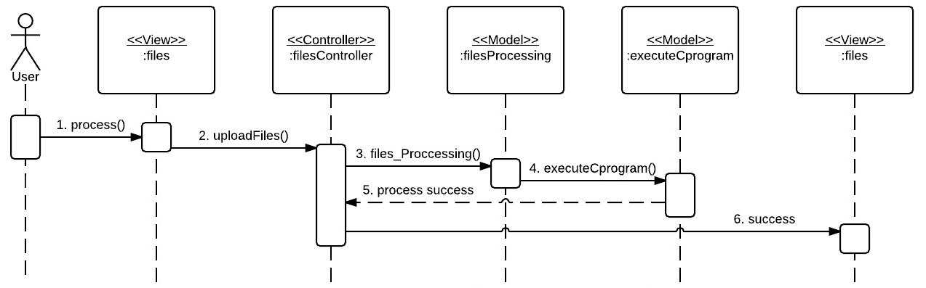

*Figure 33 - Create Process Data Sequence Diagram*

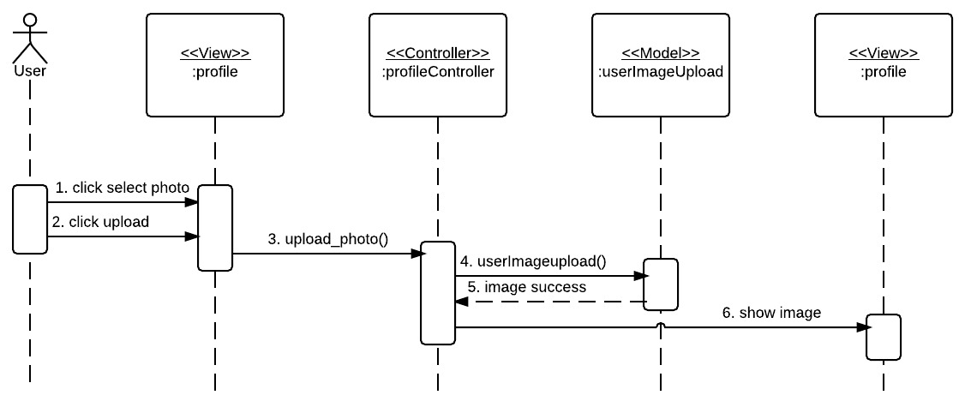

*Figure 34 - Create User Photo Upload Sequence Diagram*

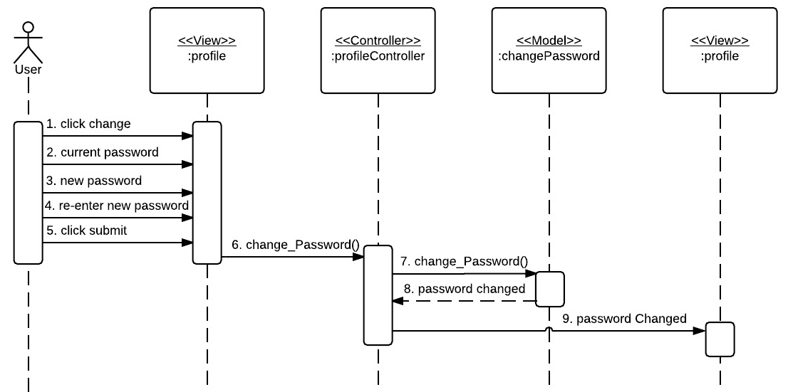

*Figure 35 - Create User Change Password Sequence Diagram*

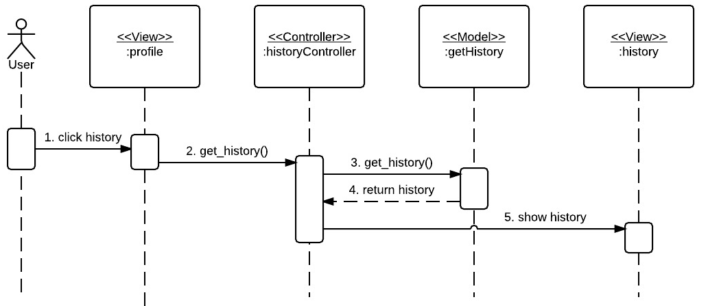

*Figure 36 - Create Document History Page Sequence Diagram*

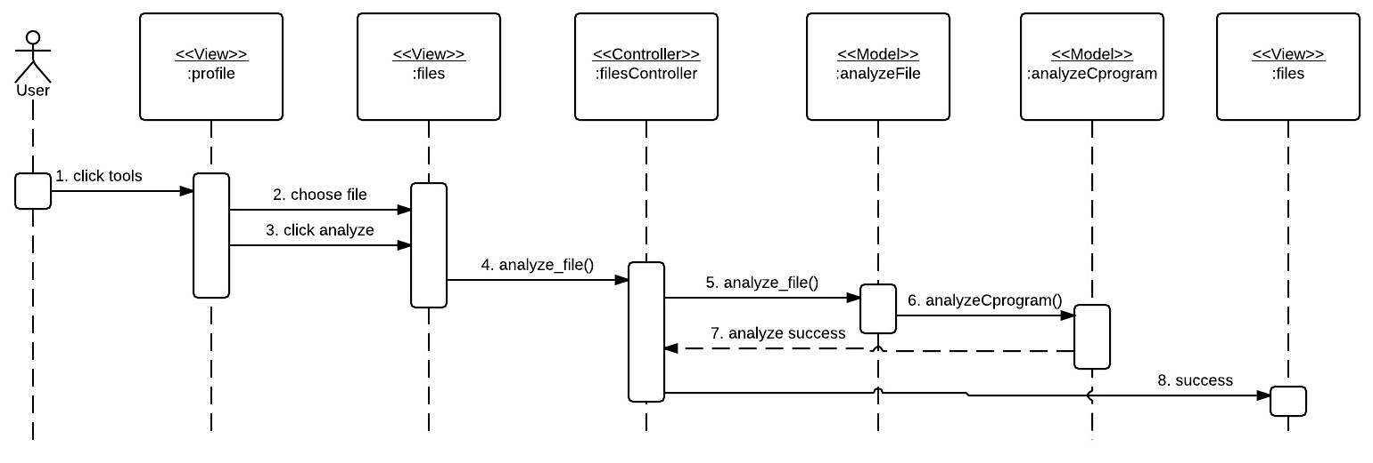

*Figure 37 - Create Analyze Data Types Sequence Diagram*

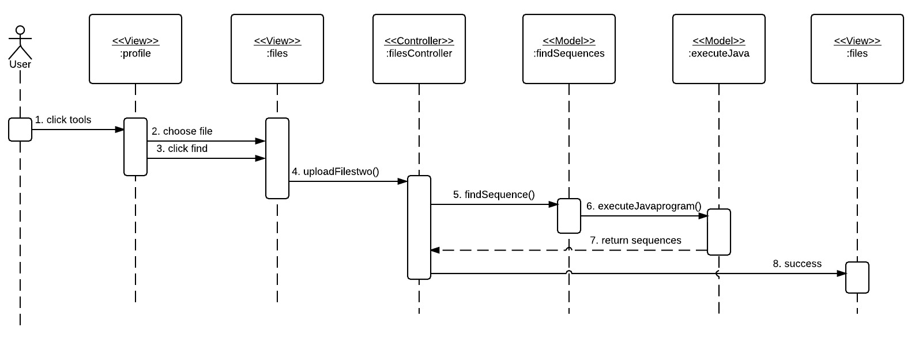

*Figure 38 - Create Find Repeated Sequences on File Sequence Diagram*

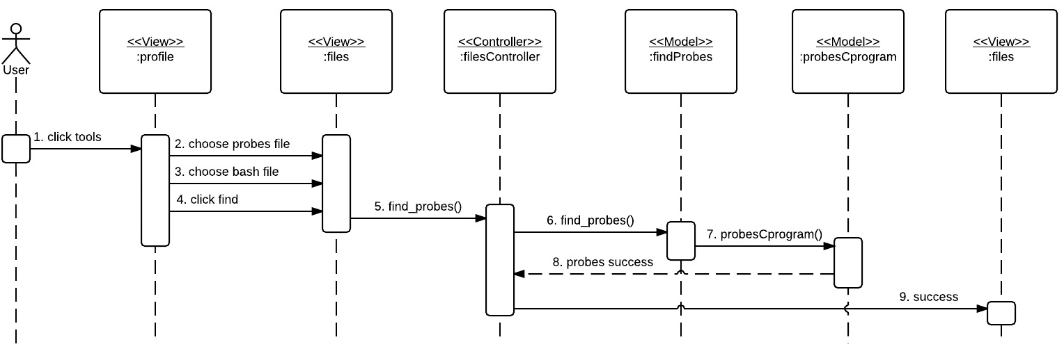

*Figure 39 - Create Find Genomic Probes Sequence Diagram*

## 

*Figure 40 - Download Files from History Sequence Diagram*

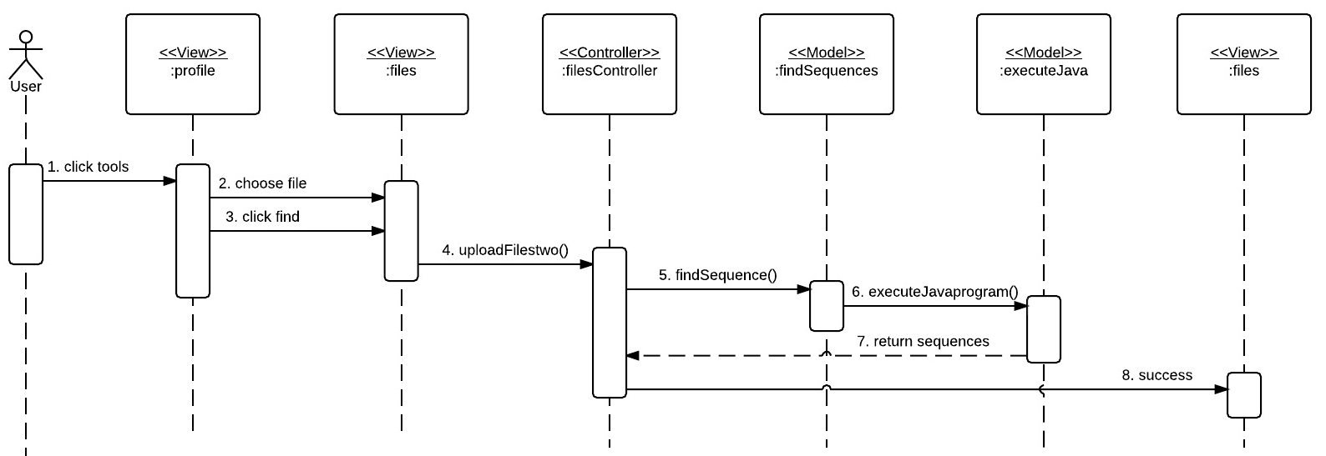

*Figure 41 - Find Location, Distances and Repeated Sequence Diagram*

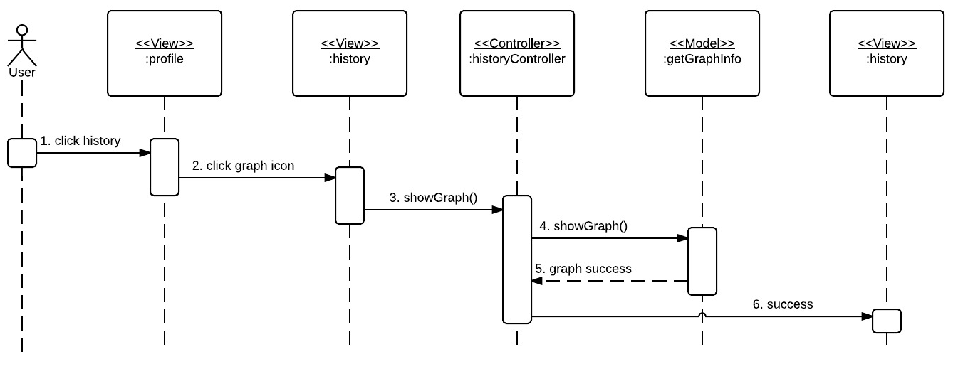

*Figure 42 - Create Visual Graph of Repeated Sequence Diagram*

## 

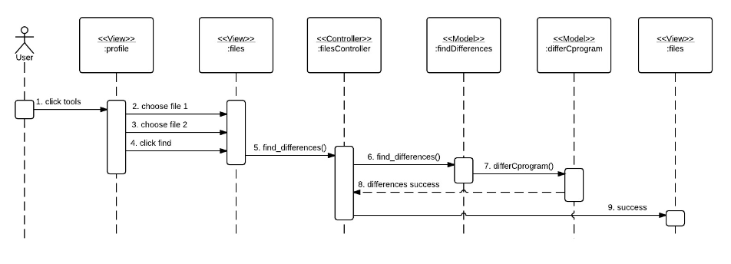

*Figure 43 - Find Differences Among Files Sequence Diagram*

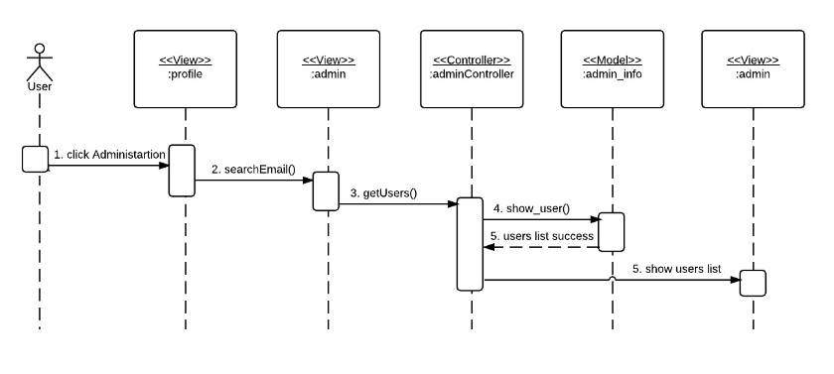

*Figure 44 - Admin Management Page Sequence Diagram*

## 

## Appendix B - User Interface Design

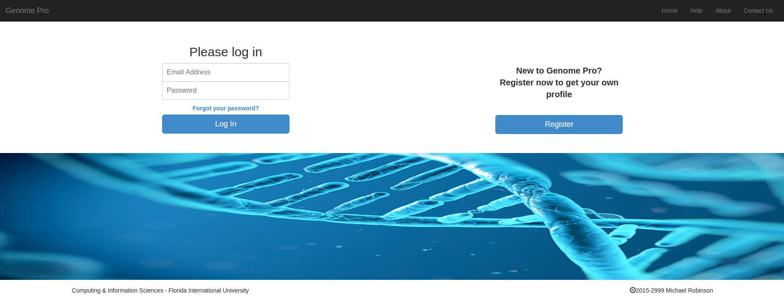

Figure 45 - Main Page

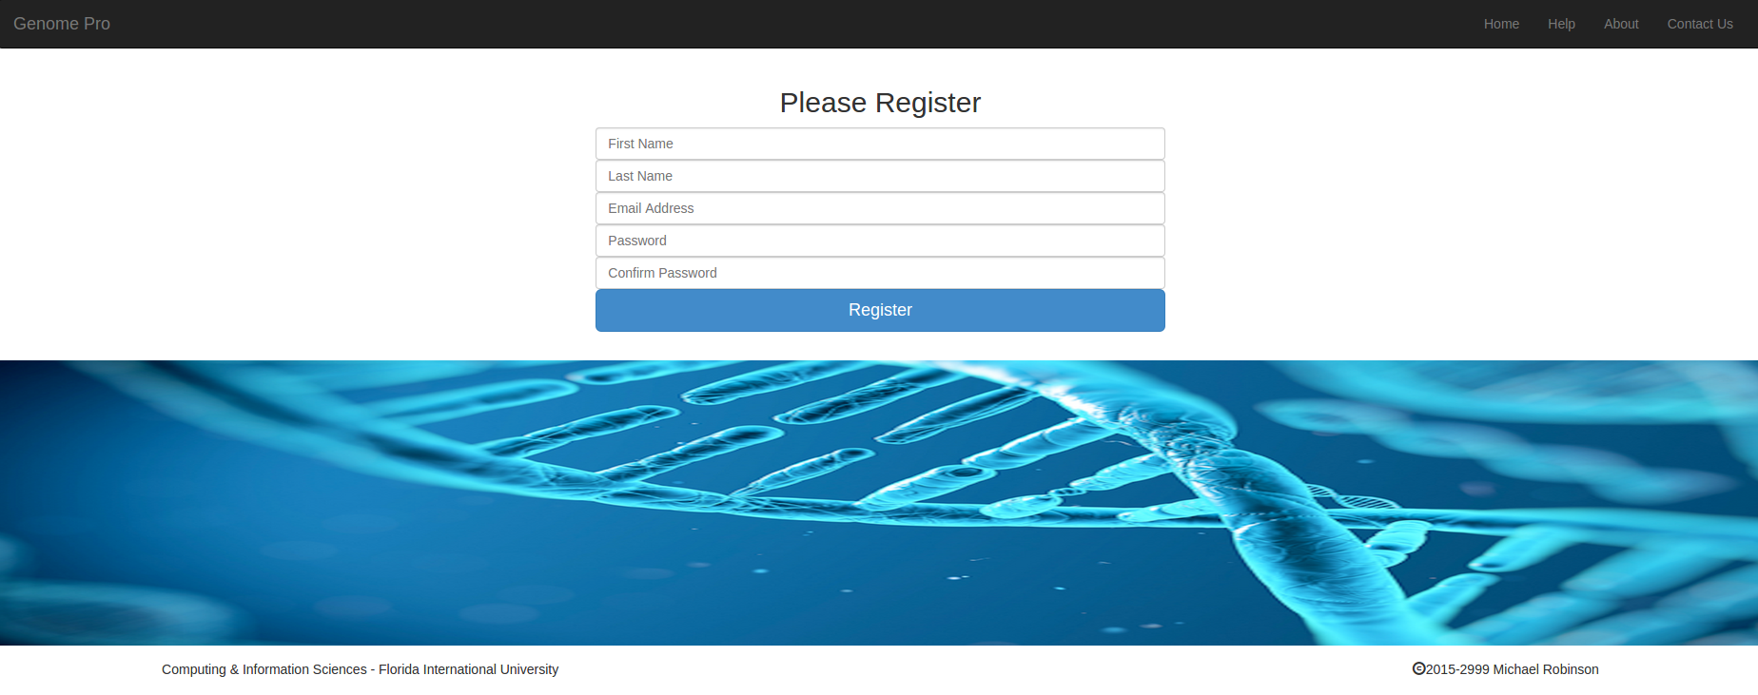

Figure 46 - Register Page

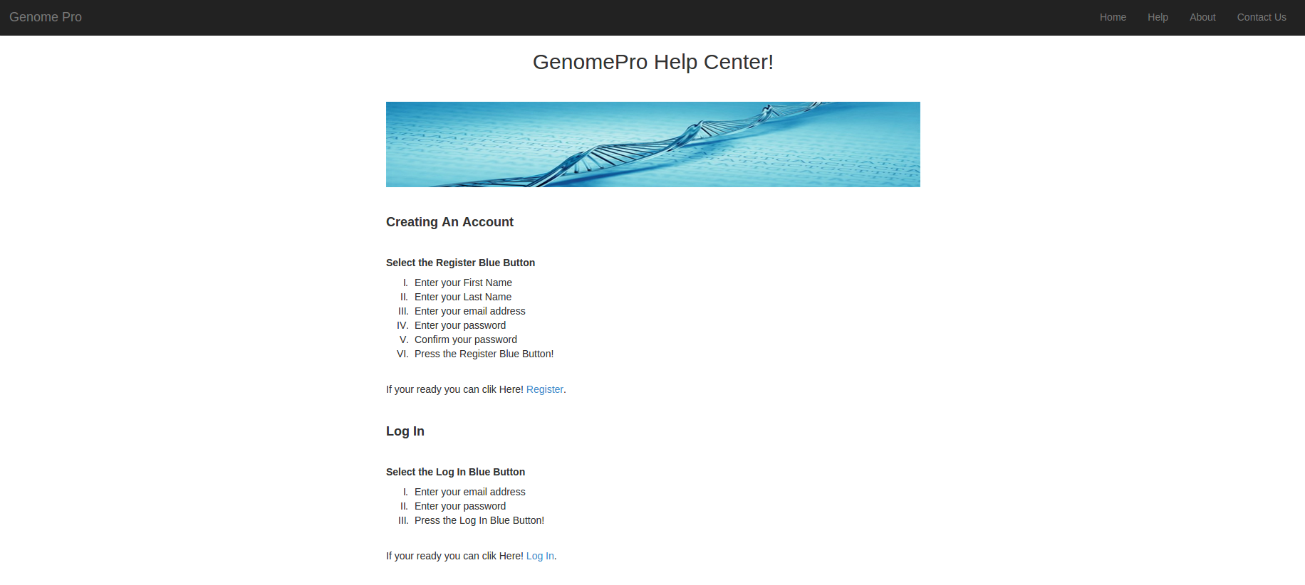

*Figure 47 - Help Page*

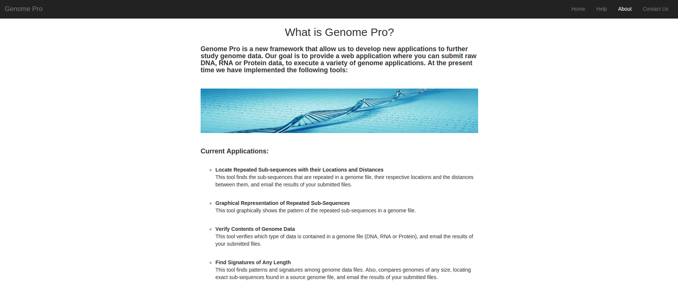

*Figure 48 - About Page*

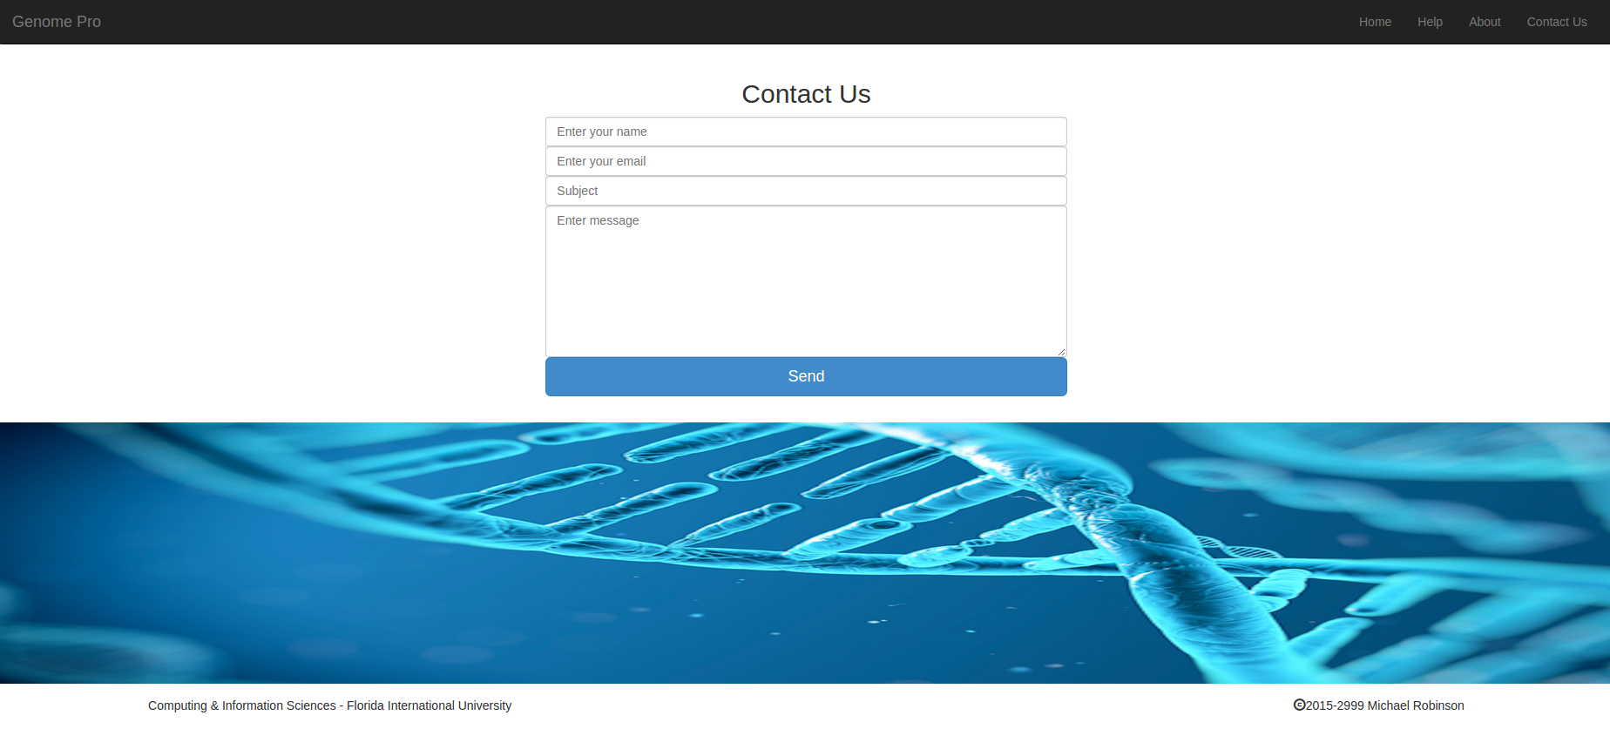

Figure 49 - Contact Us Page

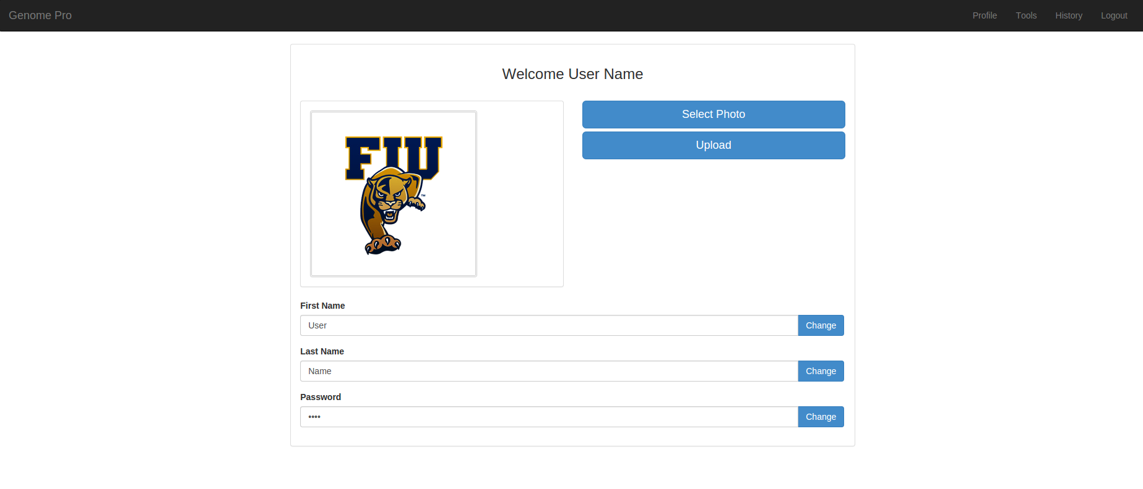

*Figure 50 - Profile Page*

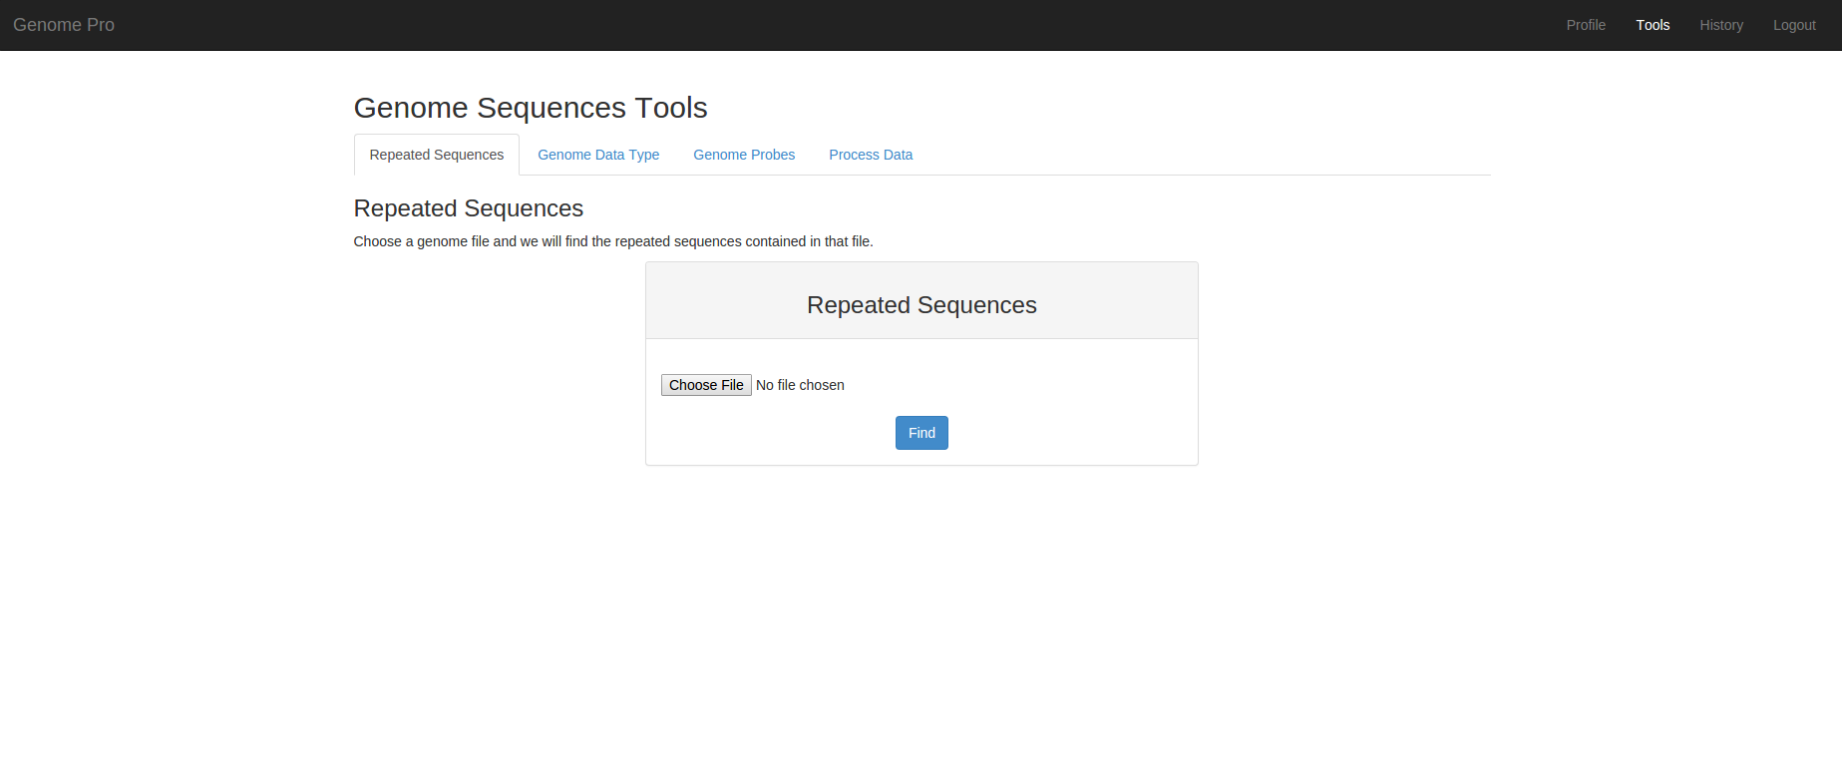

*Figure 51 - Genome Pro Tools Page*

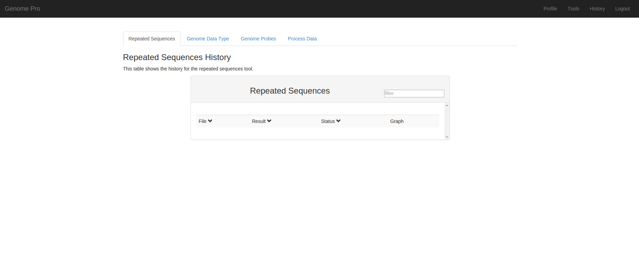

*Figure 52 - Files History Page*

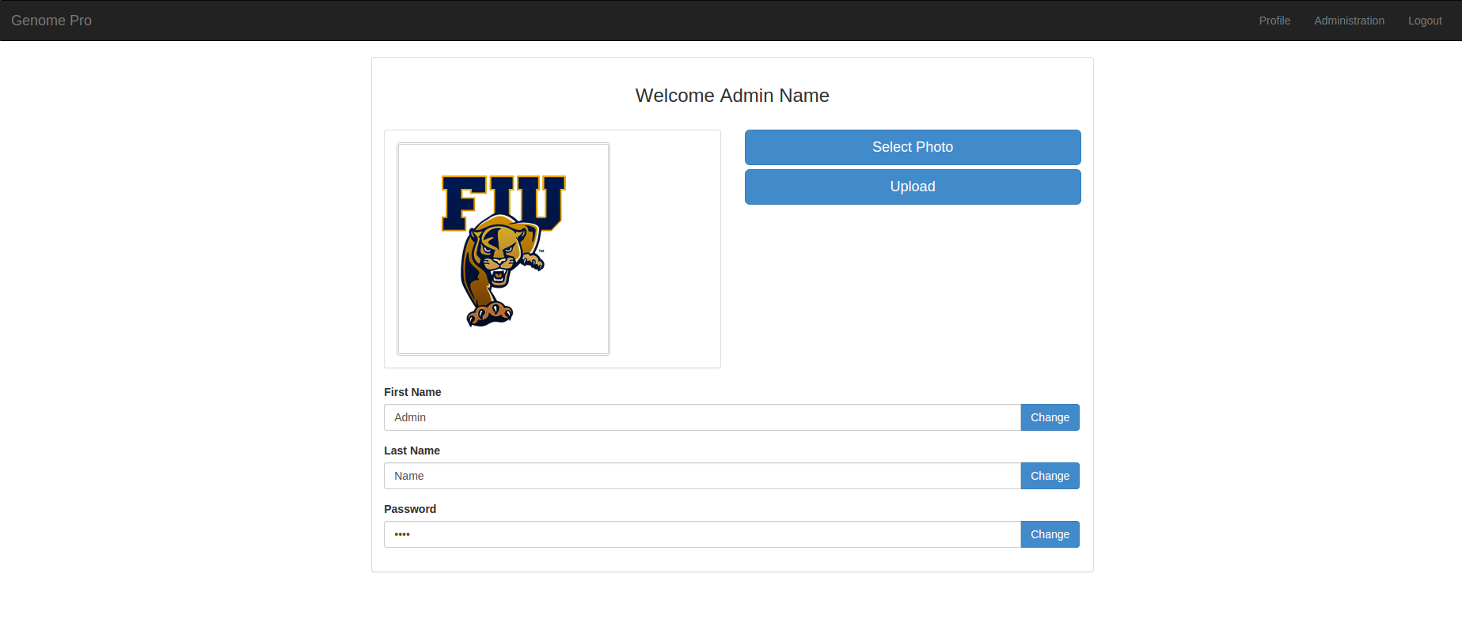

*Figure 53 - Admin Profile Page*

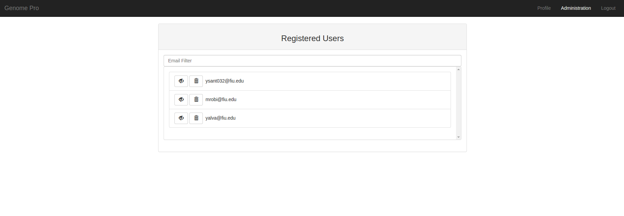

*Figure 54 - Admin Management Page*

Appendix C - Sprint Review Reports

**Sprint 1 Report**

**Date:** May 29, 2015

**Attendees:** Dr. Michael Robinson, Dr. Masoud Sadjadi, Yordan Alvarez, Yohan Santos

**Discussed Topics:** Sprint Review and planning.

Considering the initial goals, user stories description, and acceptance criteria, the team and product owner are very satisfied with what was achieved during the first sprint. The following user stories were developed and presented in a demo fashion to the product owner and instructor. These user stories were carefully reviewed and approved by them, for the reason that they meet the description and acceptance criteria required. These are the user stories that were developed during this sprint:

* Login
* Log out
* Create Forgot password
* Create User Registration
* Create User Profile

**Sprint 2 Report**

**Date:** June 12, 2015

**Attendees:** Dr. Michael Robinson, Dr. Masoud Sadjadi, Yordan Alvarez, Yohan Santos

**Discussed Topics:** Sprint Review and planning.

Considering the goals defined for this sprint, user stories description that were not completely clear, and acceptance criteria, the team and product owner are very satisfied with what was achieved during the second sprint. The following user stories were renamed, developed and presented in a demo fashion to the product owner and instructor. These user stories were carefully reviewed and approved by the product owner, for the reason that they meet the description and acceptance criteria required by him. These are the user stories that were developed during this sprint:

* Create Contact Us Page
* Create Process Data
* Create Admin Profile
* Create User Files Upload Page

**Sprint 3 Report**

**Date:** June 26, 2015

**Attendees:** Dr. Michael Robinson, Dr. Masoud Sadjadi, Yordan Alvarez, Yohan Santos

**Discussed Topics:** Sprint Review and planning.

Considering the initial goals, user stories description, and acceptance criteria, the team and product owner are once again very satisfied with what was achieved during the third sprint. All the user stories that were planned to be developed are completed. The following user stories were developed and presented in a demo fashion to the product owner and instructor. These user stories were carefully reviewed and approved by them, for the reason that they meet the description and acceptance criteria required. These are the user stories that were developed during this sprint:

* Create Document History Page
* Create Analyze Data Type
* Create Change Password
* Create User Photo Upload
* Create Find Repeated Sequences

**Sprint 4 Report**

**Date:** May 29, 2015

**Attendees:** Dr. Michael Robinson, Dr. Masoud Sadjadi, Yordan Alvarez, Yohan Santos

**Discussed Topics:** Sprint Review and planning.

Considering the initial goals, user stories description, and acceptance criteria, the team and product owner are very satisfied with what was achieved during the fourth sprint. The following user stories were developed and presented in a demo fashion to the product owner and instructor. These user stories were carefully reviewed and approved by them, for the reason that they meet the description and acceptance criteria required. These are the user stories that were developed during this sprint:

* Create Find Genomic Probes
* Download Files From History
* Find Location of Repeated Sequences
* Create Visual Graph of Repeated Sequences

**Sprint 5 Report**

**Date:** May 29, 2015

**Attendees:** Dr. Michael Robinson, Dr. Masoud Sadjadi, Yordan Alvarez, Yohan Santos

**Discussed Topics:** Sprint Review and planning.

Considering the initial goals, user stories description, and acceptance criteria, the team and product owner are very satisfied with what was achieved during sprint five and whole semester overall. The following user stories were developed and presented in a demo fashion to the product owner and instructor. These user stories were carefully reviewed and approved by them, for the reason that they meet the description and acceptance criteria required. In addition to this user stories, the team also finished up all the documentation remaining and features of the application that were incomplete in order to consider the application to be ready for release. These are the user stories that were developed during this sprint:

* Create Find Differences Among Files
* Create Admin Management Page

## 

## 

## 

## 

## 

## 

## 

## 

## 

## Appendix D - Sprint Retrospective Reports

**Sprint 1 Retrospective**

**Date:** May 29, 2015

**Attendees:** Dr. Michael Robinson, Dr. Masoud Sadjadi, Yordan Alvarez, Yohan Santos

**Discussed Topics:** Sprint Review and planning.

During the first sprint the team was able to successfully develop a great initial product that meet the needs and requirements of the product owner. This was possible due to the desire, effort, and communication between the team members. The team was able to keep up with a work schedule and perform well on the assigned user stories. Also, communication between the team and product owner was part of the success. Some of the development tools that are being used to develop this application were known by the team. On the other hand, the team needed to learn in a fast paced some of the other tools required that were not previously used or known by the team, but the team instead consider this types of constraints as a learning process that can be beneficial for the future.

**Sprint 2 Retrospective**

**Date:** June 12, 2015

**Attendees:** Dr. Michael Robinson, Dr. Masoud Sadjadi, Yordan Alvarez, Yohan Santos

**Discussed Topics:** Sprint Review and planning.

During the second sprint the team was able to successfully develop all the user stories that meet the needs and requirements of the product owner. This was possible due to the desire, effort, and communication between the team members. The team was able to keep up with a work schedule and complete the assigned user stories. However, the description for two of the four user stories that were developed were not clear enough on what benefit the user was obtaining from them. Therefore, the team needed to rename the description for those user stories and agreed-upon with the instructor to provide a clear user based description user story for the next sprint.

**Sprint 3 Retrospective**

**Date:** June 26, 2015

**Attendees:** Dr. Michael Robinson, Dr. Masoud Sadjadi, Yordan Alvarez, Yohan Santos

**Discussed Topics:** Sprint Review and planning.

During the third sprint the team was able to successfully develop all the user stories that meet the needs and requirements of the product owner. This was possible due to the desire, effort, and communication between the team members. The team was able to keep up with a work schedule and complete the assigned user stories. However, there were some errors in the documentation pointed out by the instructor. Also, the instructor advised the team about putting more work into the actual domain of the application instead of working on general features of the application. Therefore, the team has planned on working on features focused on the domain of the application for the upcoming two sprints.

**Sprint 4 Retrospective**

**Date:** May 29, 2015

**Attendees:** Dr. Michael Robinson, Dr. Masoud Sadjadi, Yordan Alvarez, Yohan Santos

**Discussed Topics:** Sprint Review and planning.

During the fourth sprint the team was able to successfully develop a great set of tools that will help the users achieve major points on their research. This was possible due to the desire, effort, and communication between the team members. The team was able to keep up with a work schedule and perform well on the assigned user stories. Also, communication between the team and product owner was part of the success. On the other hand, the team needed to learn in a fast paced some new library tools that were not previously used or known by the team, but the team instead consider this types of constraints as a learning process that can be beneficial for the future. To conclude, the team is very satisfied with the comments and feedback of both the instructor and product owner.

**Sprint 5 Retrospective**

**Date:** May 29, 2015

**Attendees:** Dr. Michael Robinson, Dr. Masoud Sadjadi, Yordan Alvarez, Yohan Santos

**Discussed Topics:** Sprint Review and planning.

During the fifth sprint the team was able to successfully develop the last set of tools that will help the users achieve major points on their research. Also, at this stage the team and product owner considered the application to be completely done and ready for release. This was possible due to the desire, effort, and communication between the team members. In addition, communication between the team and product owner was part of the success. To conclude, the team is very satisfied with the comments and feedback from both the instructor and product owner.

**Appendix E - Manuals**

**Appendix E - Part 1 User Manual**

This section is intended to explain to the **User how to use our web application** by parts in order to have a better experience using the Genome Pro web application.

**Step 1:**

First, you will need two basic things, number **1** a device and number **2** a web browser:

**1**  **2** 

Then, you will be able to find the Genome Pro web application URL at: **http://genomepro.cis.fiu.edu**

**Step 2:**

Once you are in the Genome Pro web application you should see the main page:



There you have two options **login into** the system if you already have a Genome Pro account or **register** if you are new to Genome Pro. Step 3 will guide you on how to **register**.

**Step 3:**

First, you need to click on the **blue button** that says **register** on the **main page**. Once you click it, you will see the registration page that looks like this:



Then you will need to enter the corresponding information into the fields. You will need to enter your **First Name**, **Last Name**, **Email Address**, **Password**, and **Confirm Password**. Next you can click on the **blue button** that says **register**.

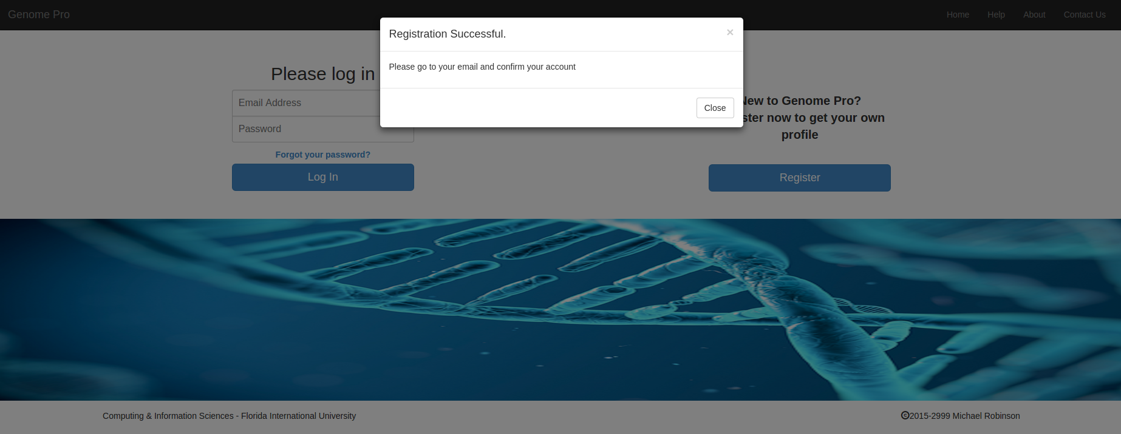

The system will automatically send you an **email confirmation** to the email you provided. To finish the registration process, you will need to **click on the link** that was sent to your email.

**Step 4:**

Step 4 will guide you how to **log into the system** if you already have an account. First, you will need to enter your **Email Address** and **Password** on the **main page**. Then you need to click in the **blue button** that says **Log in**. Once you click on **Login,** the system will redirect you to **your profile page** that will looks like this:



**Step 5:**

Step 5 will show you how to **recover your password** from the **main page** in case you lose it or forget it. You need to **click** in **Forgot your password link** located below the **Login** button. Once you **click it,** an **alert box** will appear that looks like the one **below**. The **alert box** will ask you to enter your **Email Address** in order to **recover your password** and then **click** on the recovery **button**. The system will send you an **email** with a **temporary password** in order for you to **log in into the system**, once you login **into your profile** you can change it.

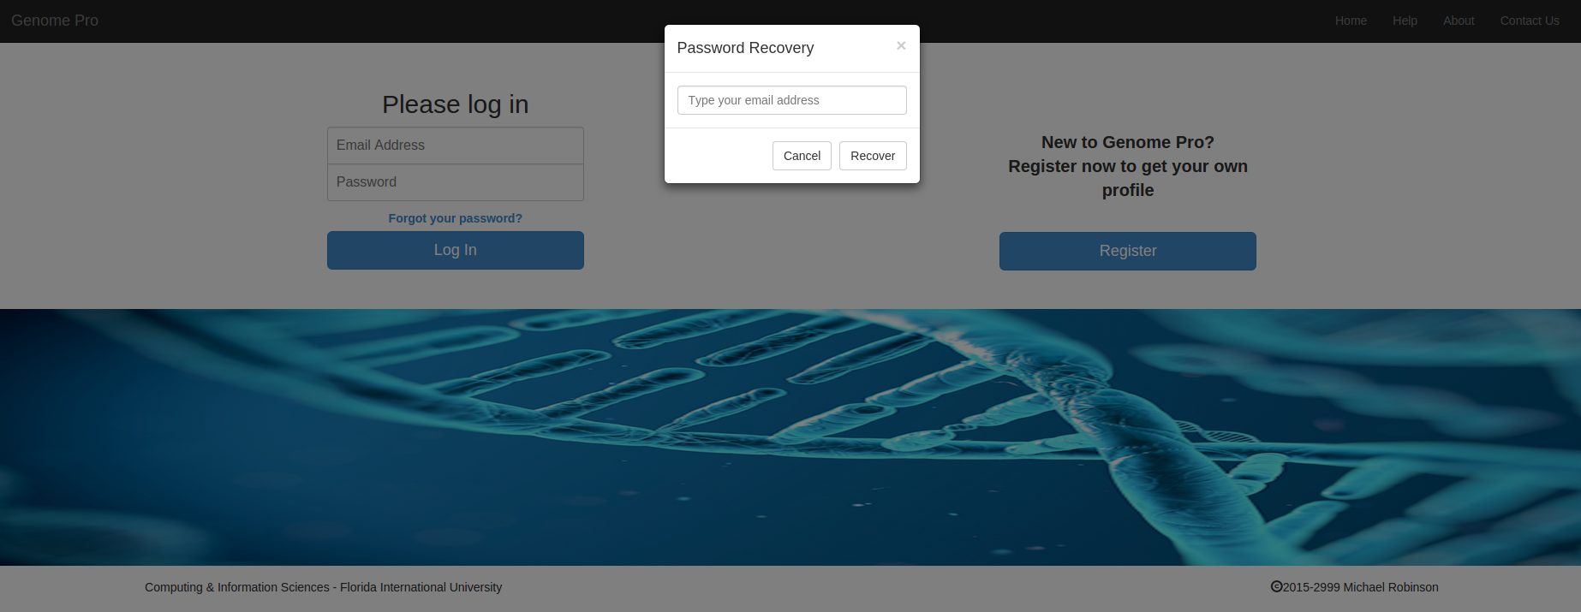

**Step 6:**

Step 6 will show you how to **Contact Us** for any issue or concern. On the **Main page or Homepage** on the menu bar you will see a **Contact Us** button **click on it**. Once that you click it will redirect you to the **Contact Us page** that look like this.



Then you will need to **fill out** the following information, **Your First Name or Full Name** preferible **Full Name** for a quickly search of the system, **Email**, **Subject**, **Message**, and then **click on Send**. The system will **popup a window** that look like below. This means that your message was sended to us.

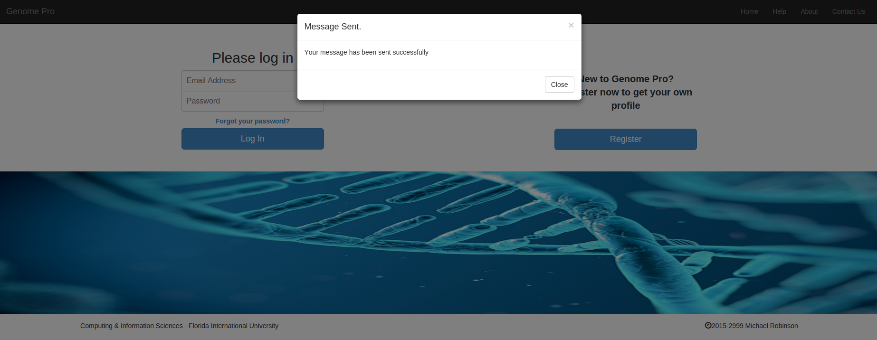

**Step 7:**

Step 7 will show you how to use the Genome Pro Tools to **upload and process genomic files** from your **Profile page**. First you will need to go to **Tools** located on the **Profile page** menu bar. You will see different **Tabs**. Each Tab have different applications, the instructions will be presented below the name of the application.

**TAB #1:**



**TAB #2:**

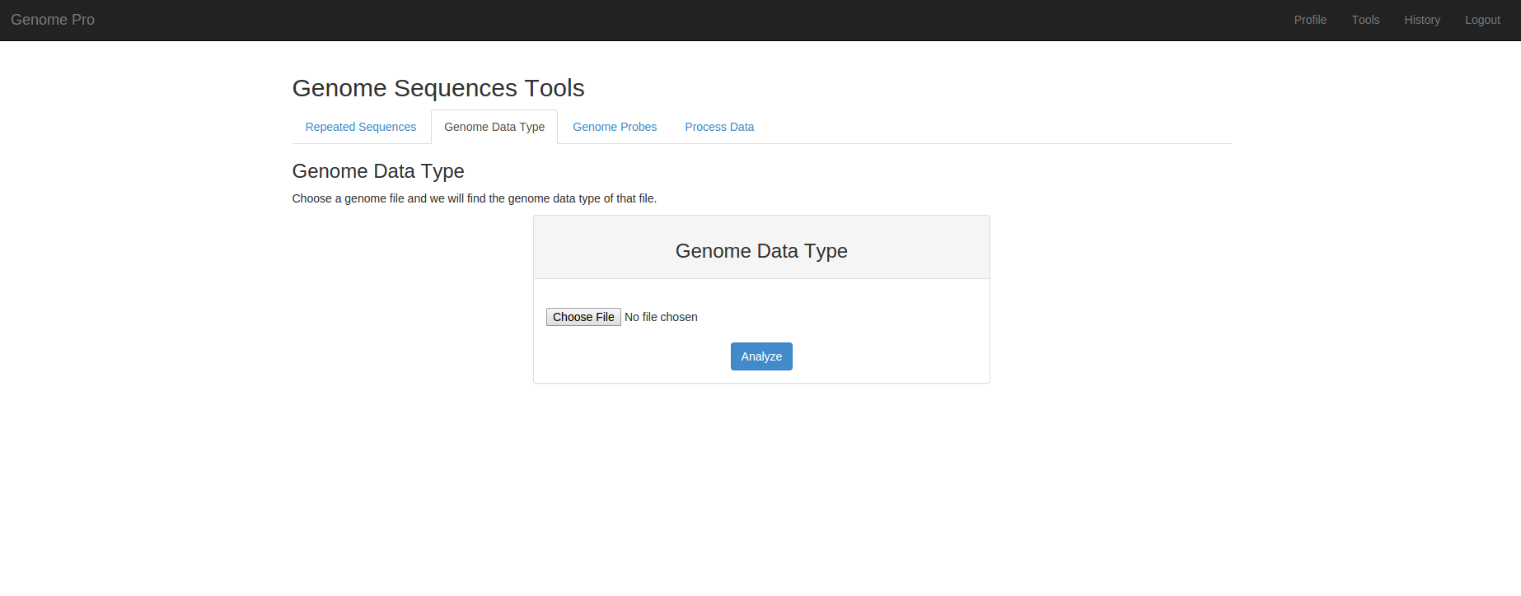

**TAB #3:**

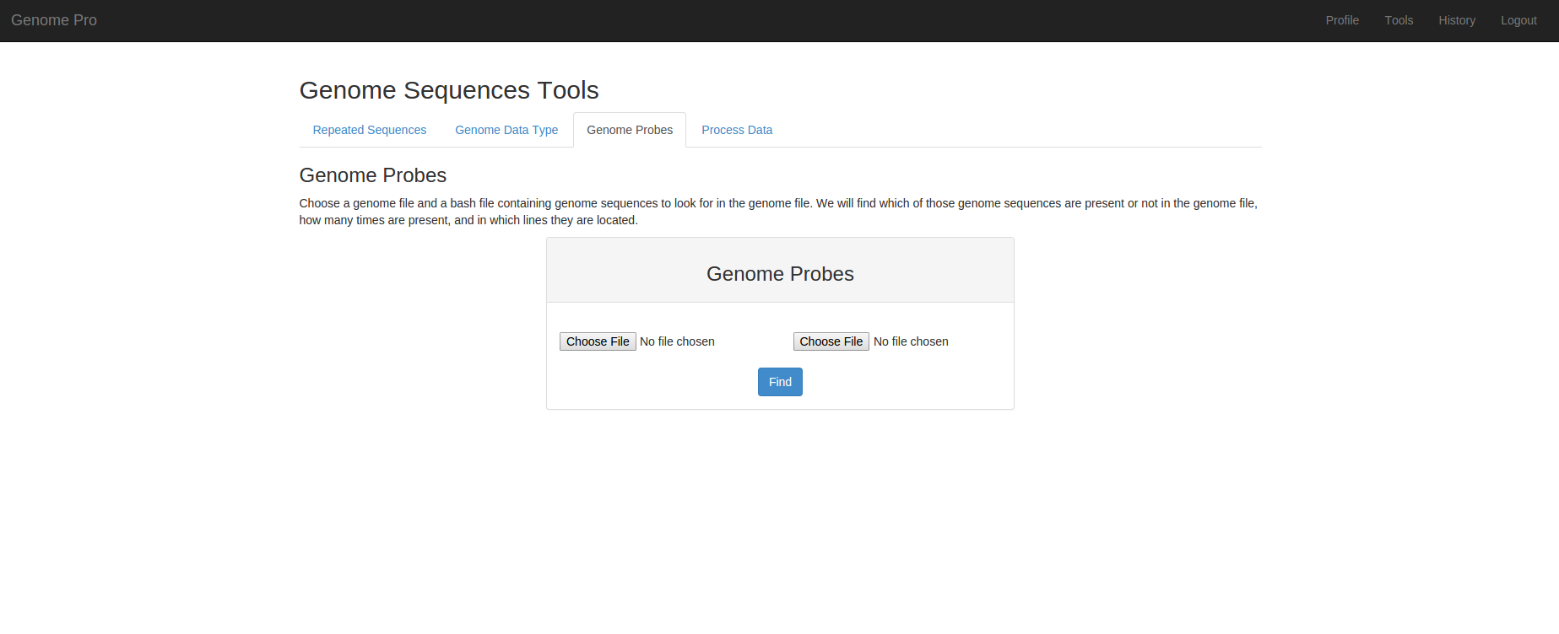

**TAB #4:**

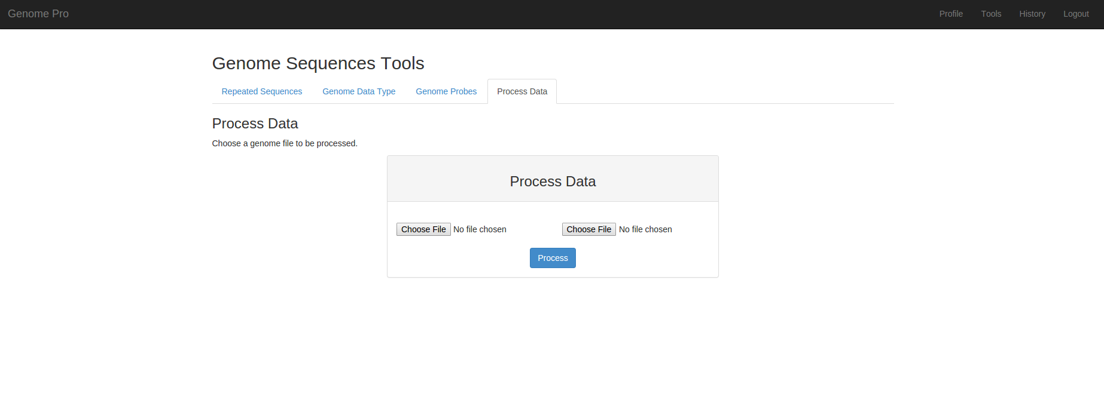

In order to **Upload and process genomic files** you will need to have the **files** ready for the system to process them. Once that you're ready you can go ahead and proceed to upload the files. Once you have finished uploading the files click in the **Blue Button** below each box. The System will **show a window** saying that the files have been uploaded correctly.

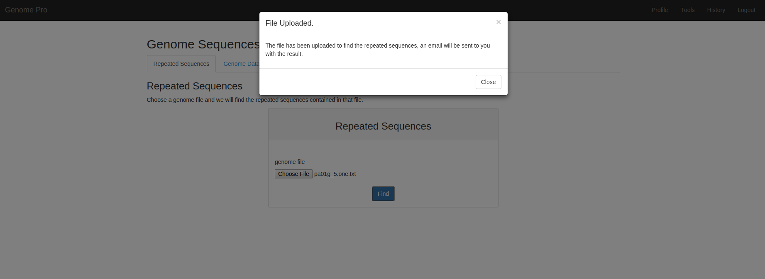

**Step 8:**

Step 8 will show you how to **see your files and results in History Page** from your **Profile page**. First you will need to go to **History** located on the **Profile page** menu bar. You will see differents **Tabs**. Each Tab contains the history for each one of the different tools. You will see your result by **clicking in the download button,** once you click it will download the file directly to **your system**.

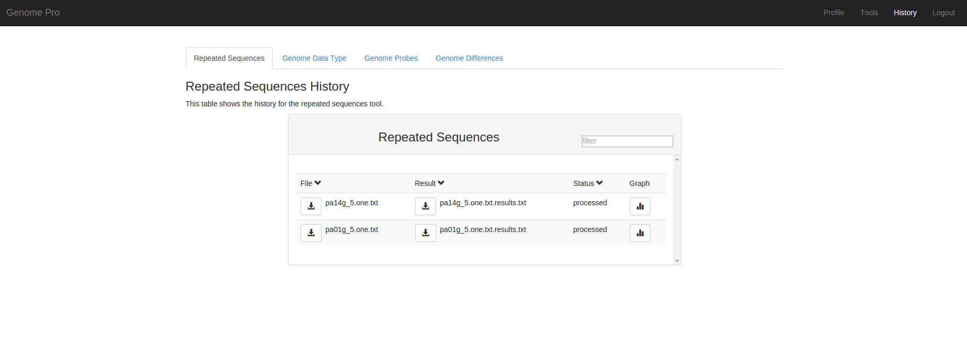

The repeated sequences history tab will allow you to see **your results** in a **graph** by clicking in a **graph icon**, the graph will look like this.

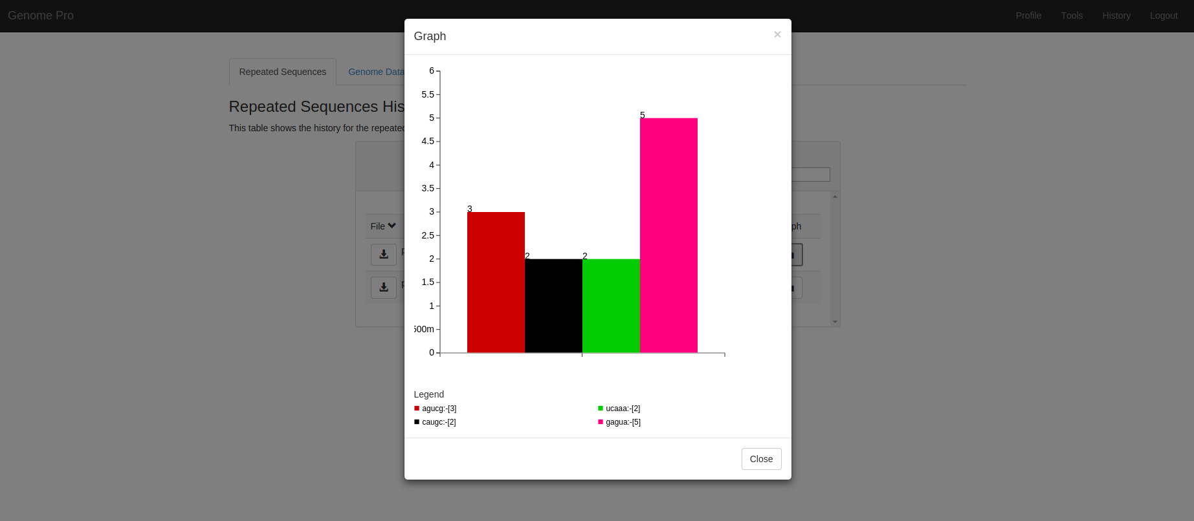

**Step 9:**

Step 9 will show you how to **change your personal information** in your **Profile page**. You will have **Four options** such as change **your profile picture,** change your **your name**, change your **last name**, and change your **password**. I will guide you by the order in which the options are displayed.



First, to change **your profile picture**, you need to click in the **Blue Button** that says **select photo**. Once you **click it,** you can **browse** for **your photo** in your system. Once you **choose your photo** you can go ahead and click in the **Blue Button** that says **Upload**. Once you Upload your photo the system will show you a message box that looks like this.

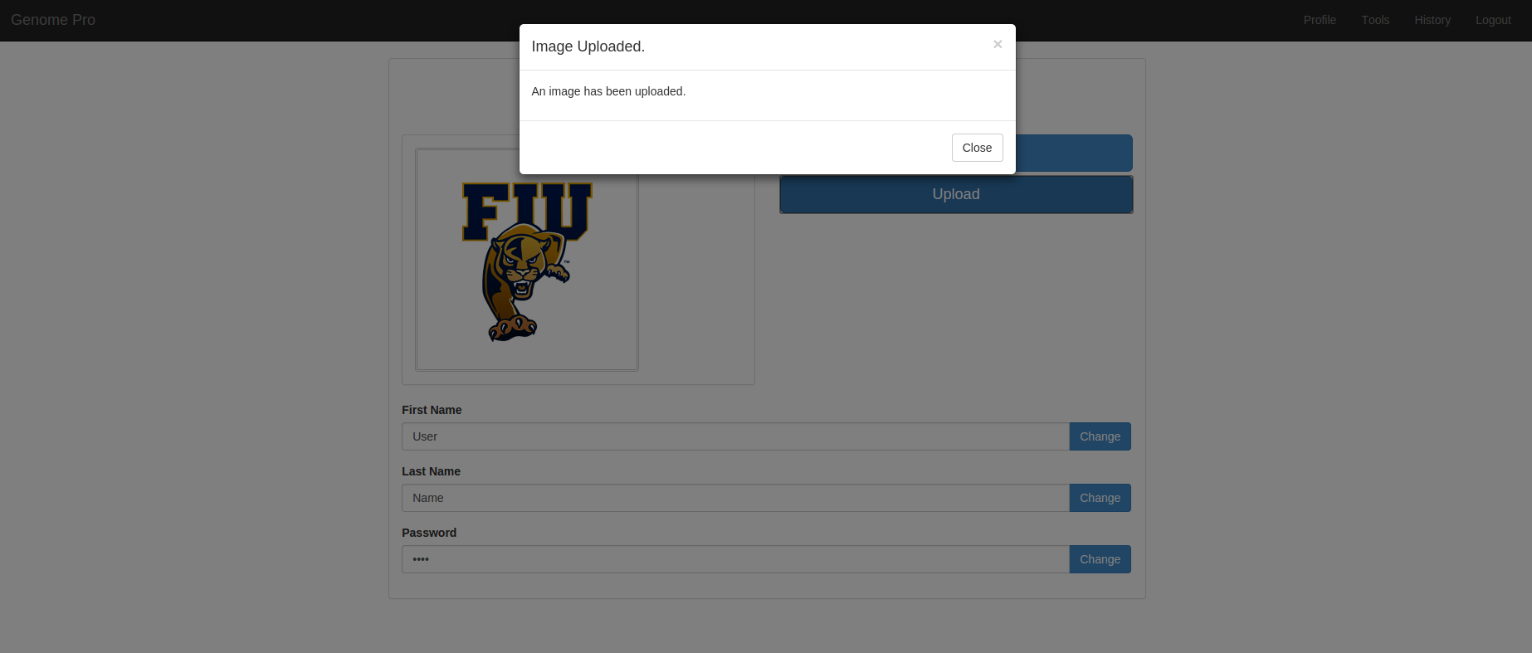

Second, to change **your first name**, you need to click in the **Blue Button** that says **change**. Once you click it, the system will **display** an **alert box** that look like this.

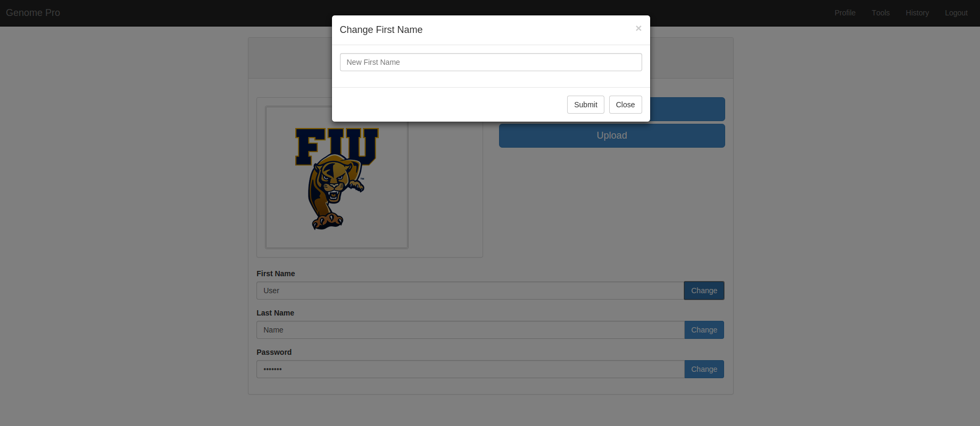

Once you submit, the system will show you a message box that look like this.

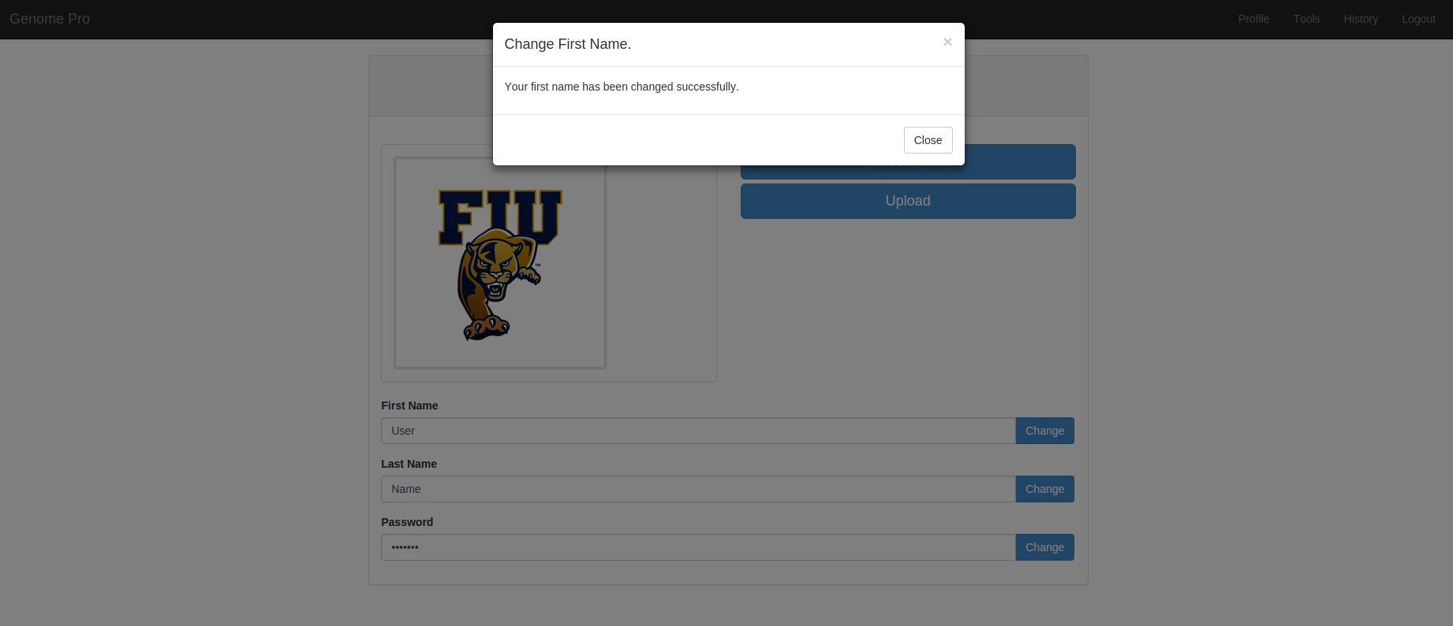

Third, to change **your last name**, you need to click in the **Blue Button** that says **change**. Once you click it, the system will **display** an **alert box** that look like this.

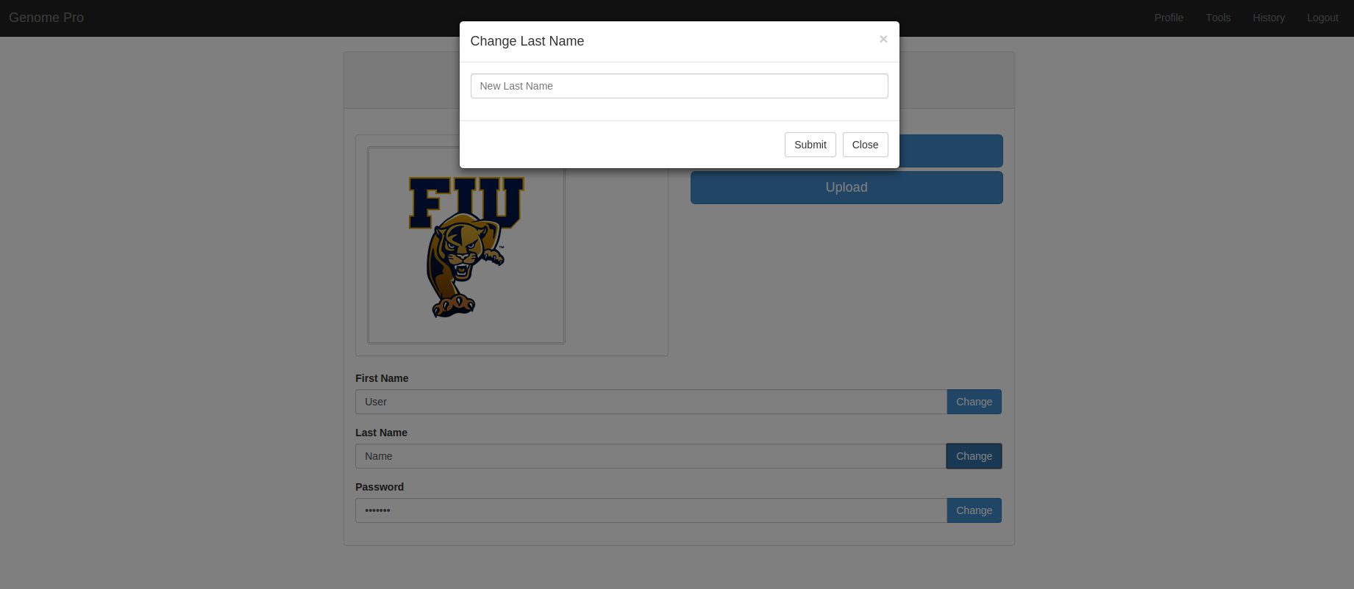

Once you submit, the system will show you a message box that look like this.

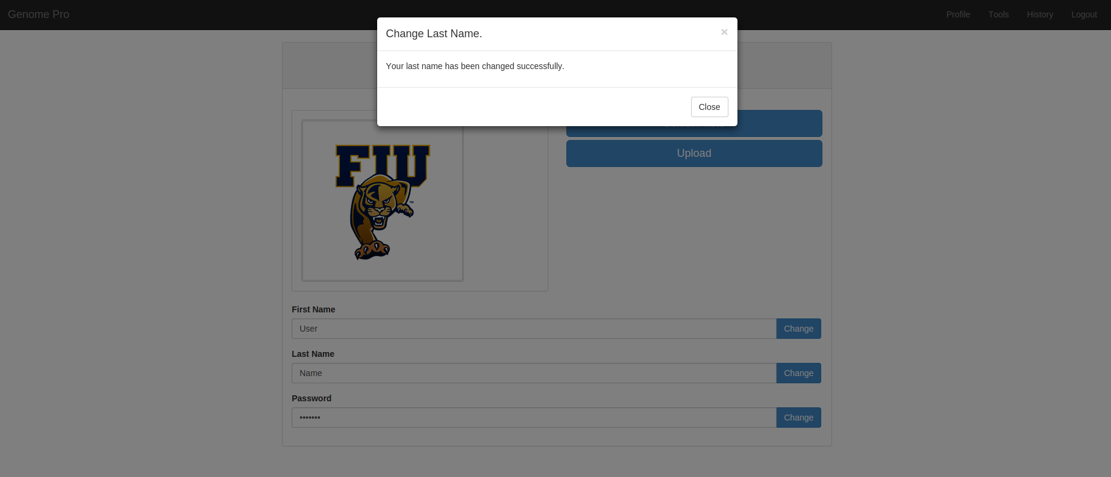

Fourth, to change **your password**, you need to click in the **Blue Button** that says **change**. Once you click it, the system will **display** an **alert box** that look like this.

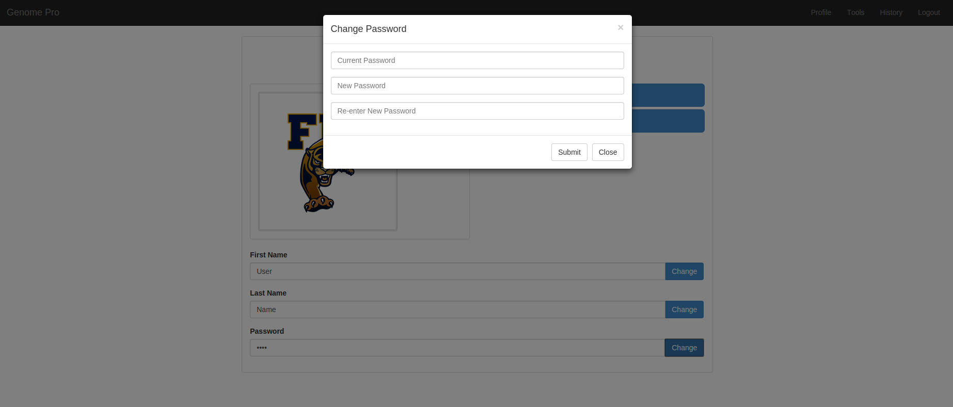

Once you submit, the system will show you a message box that look like this.

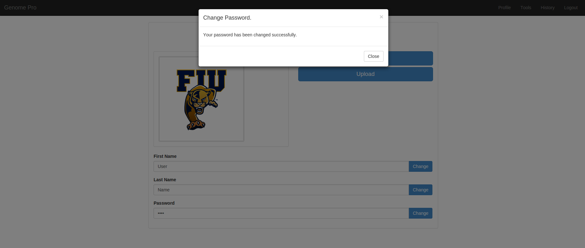

**Appendix E - Part 2 Admin Manual**

This section is intended to explain to the **Admin how to use our web application** by parts in order to have a better experience using the Genome Pro web application.

**Step 1:**

First, you will need **Three basic things**, number **1** a device, number **2** a web browser, and number **3** the most important access from the system as an **Admin**:

**1**  **2**  **3** 

Then, you will be able to find the Genome Pro web application URL at: **http://genomepro.cis.fiu.edu**

**Step 2:**

Once you are in the Genome Pro web application you should see the main page:



There you only need to go to **log in**. You will need to enter your **Admin Email** and the **Password** then click on **Log in button**. Then system will allow you access as **administrator**.

**Step 3:**

Once you log in into the system your **Admin Profile** show look like this.



**Step 4:**

Step 4 will show you how to **change your personal information** from your **Profile page**. You will have **Four options** such as change **your profile picture,** change your **your name**, change your **last name**, and change your **password**. I will guide you by the order in which the options are displayed.



First, to change **your profile picture**, you need to click in the **Blue Button** that says **select photo**. Once you **click it,** you can **browse** for **your photo** in your system. Once you **choose your photo** you can go ahead and click in the **Blue Button** that says **Upload**. Once you Upload your photo the system will show you a message box that looks like this.

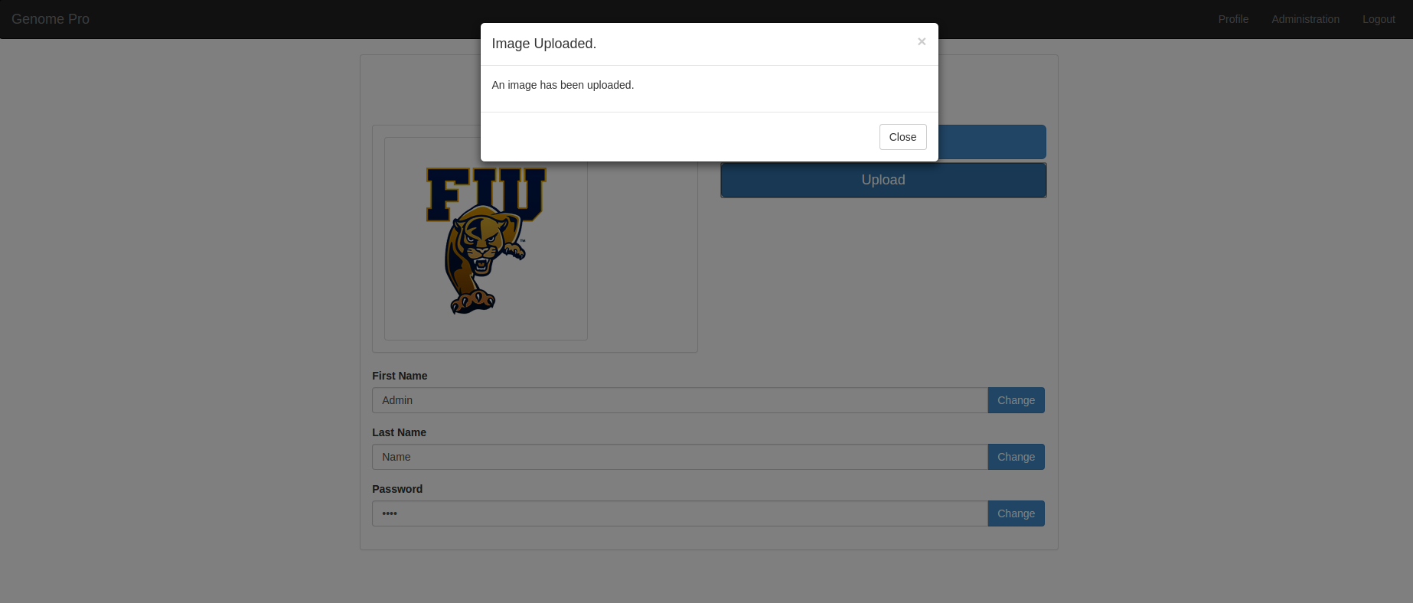

Second, to change **your first name**, you need to click in the **Blue Button** that says **change**. Once you click it, the system will **display** an **alert box** that look like this.

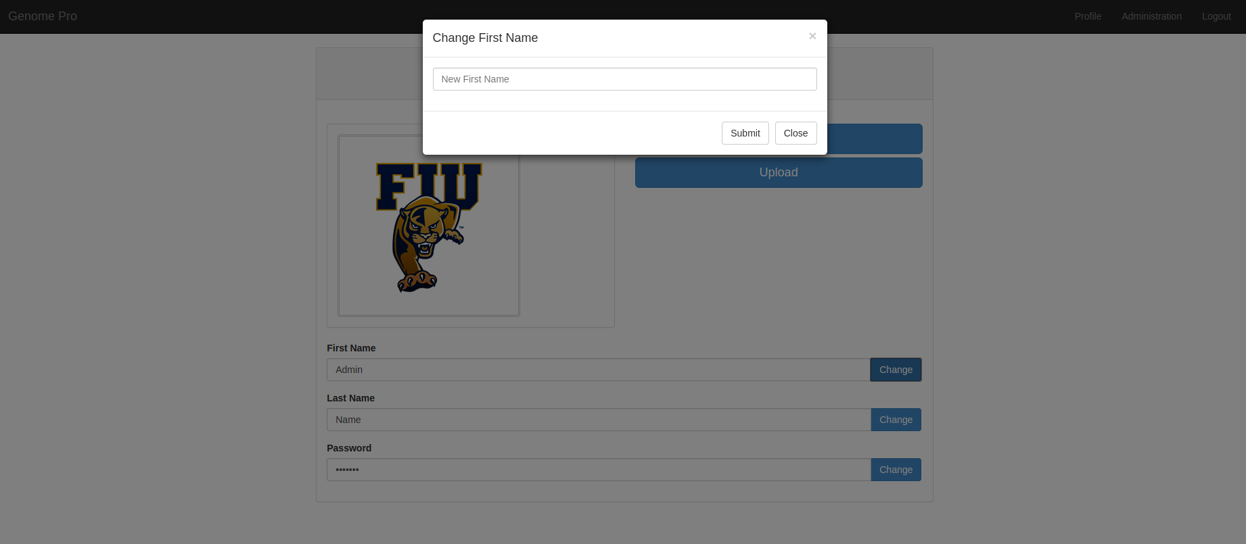

Once you submit, the system will show you a message box that look like this.

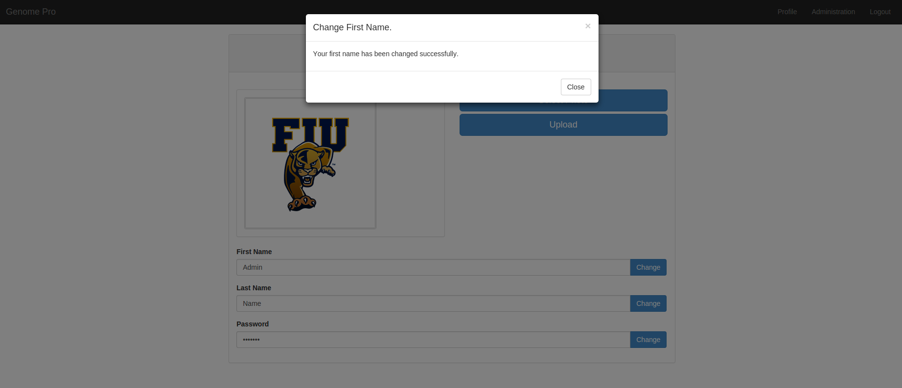

Third, to change **your last name**, you need to click in the **Blue Button** that says **change**. Once you click it, the system will **display** an **alert box** that look like this.

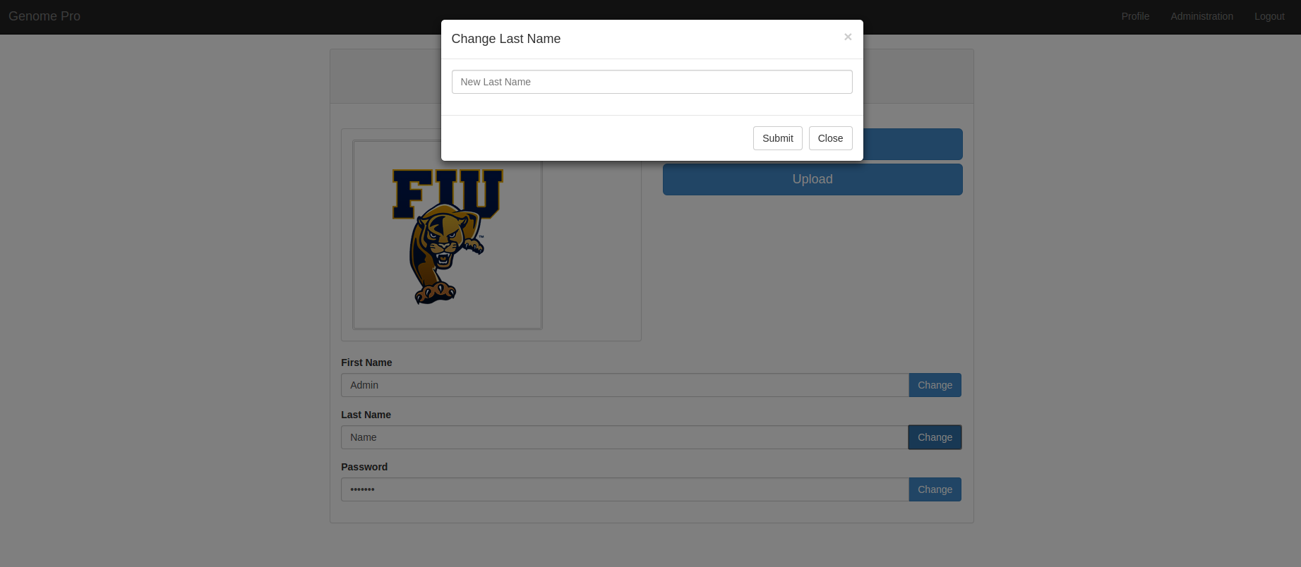

Once you submit, the system will show you a message box that look like this.

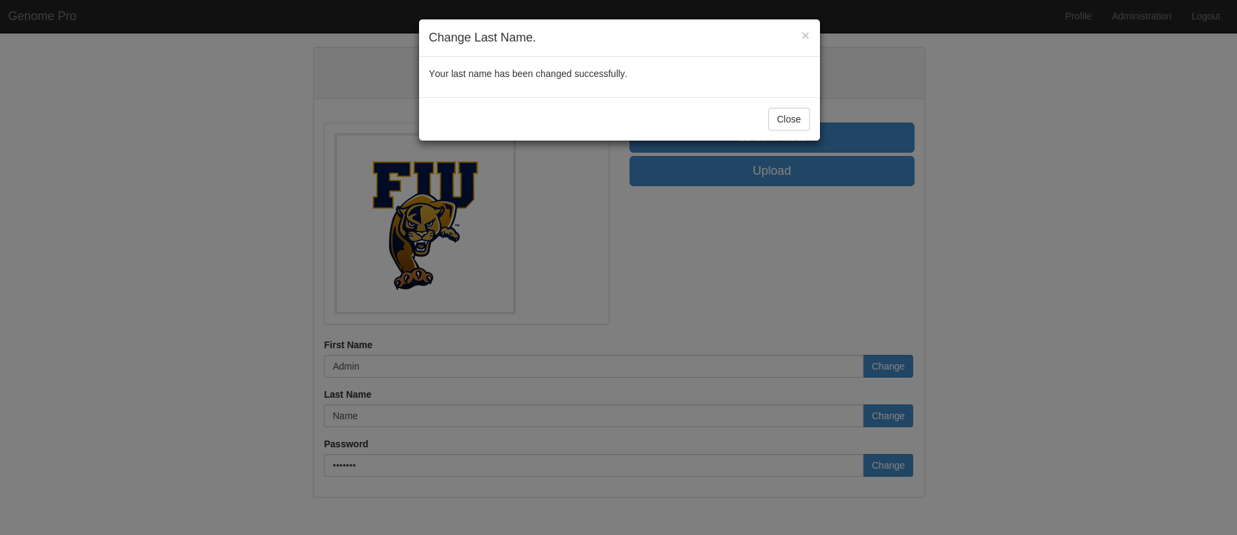

Fourth, to change **your password**, you need to click in the **Blue Button** that says **change**. Once you click it, the system will **display** an **alert box** that look like this.

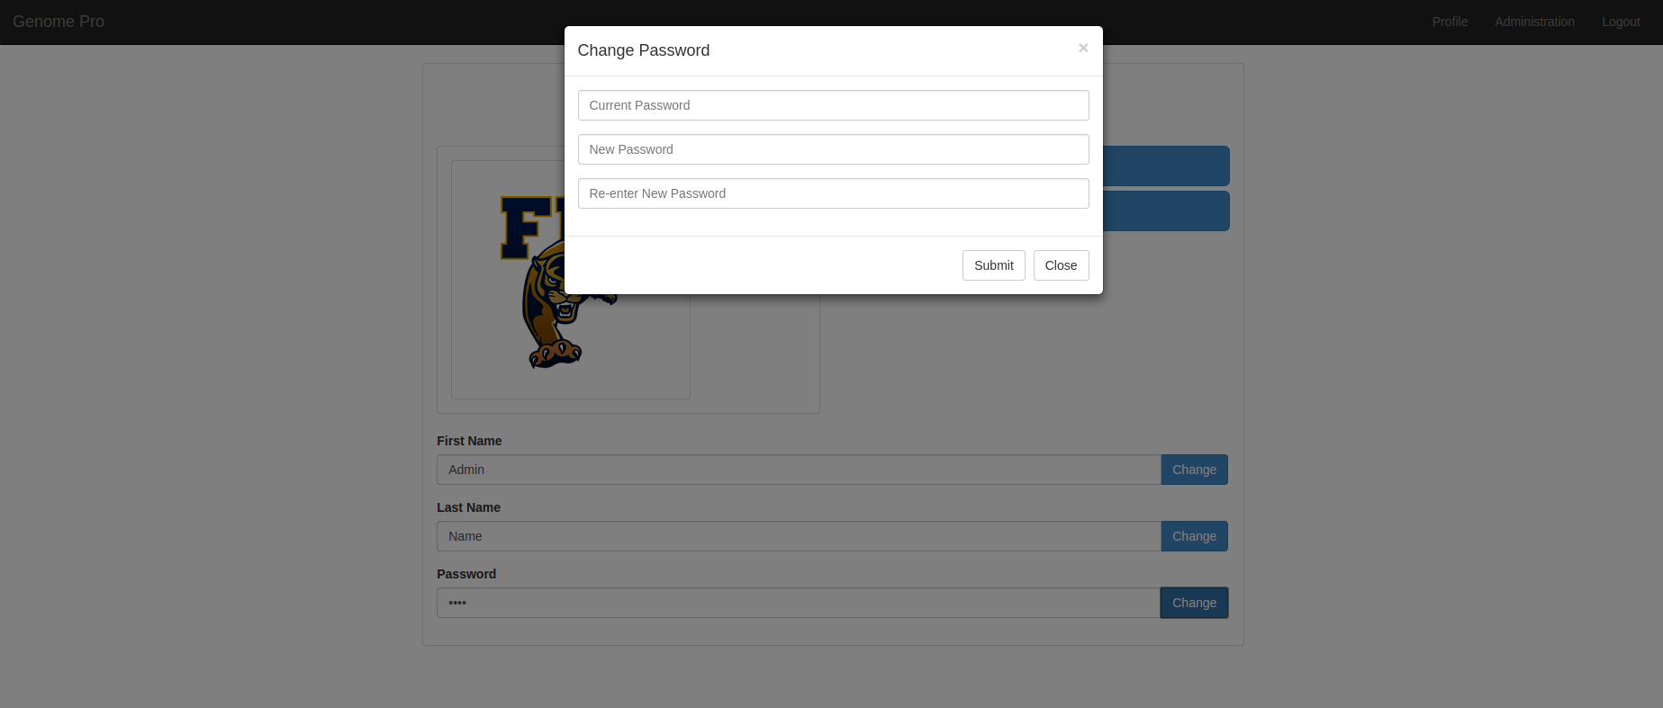

Once you submit, the system will show you a message box that look like this.

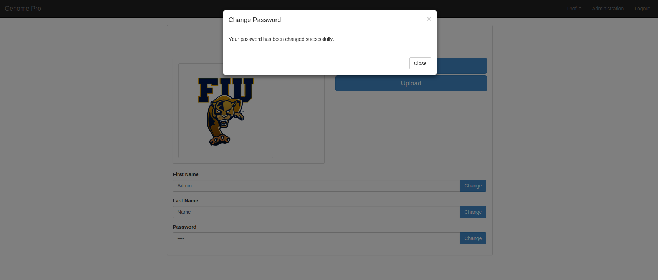

**Step 5:**

Step 5 will show you how to **manage users that are registered in the system** from your **Admin Profile page**. You will to click on the **Administration** tab in your **your profile** menu bar. It will redirect you to the **Administration Page** that looks like that.



Once you are there you will be able to **see all users** registered in the system. Also you will be able to **delete** any user from the system by **clicking** in the **Trash Can Icon.**

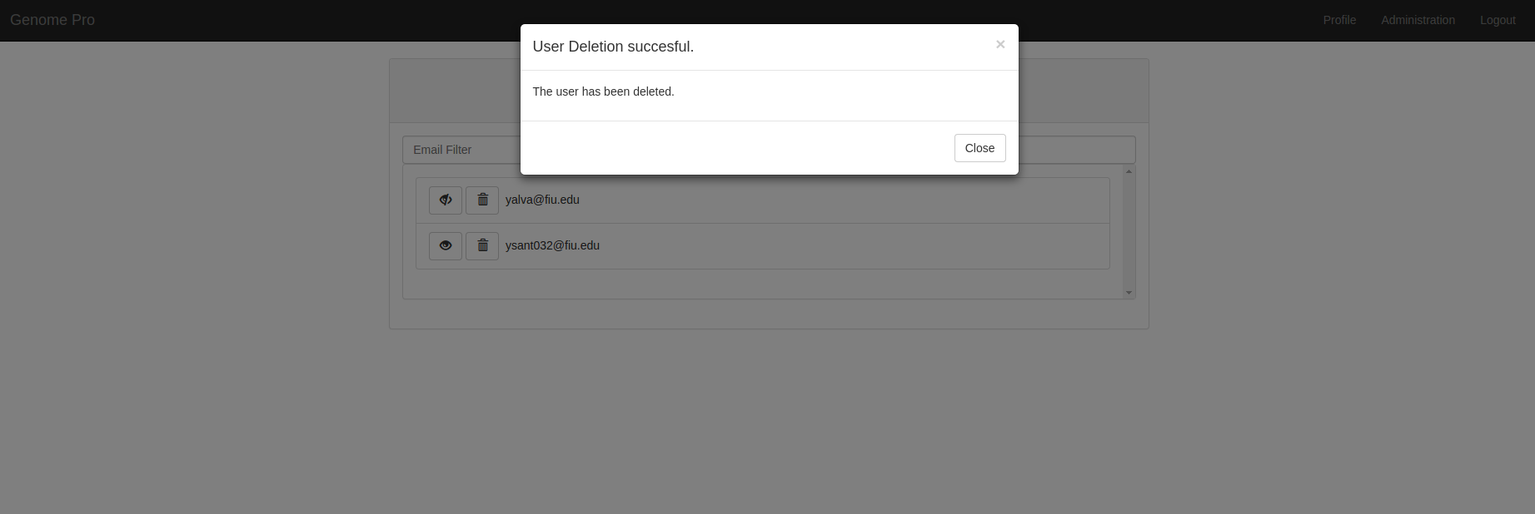

Also you will be able to change any **user Type** by **clicking** in the **Eye Icon.**

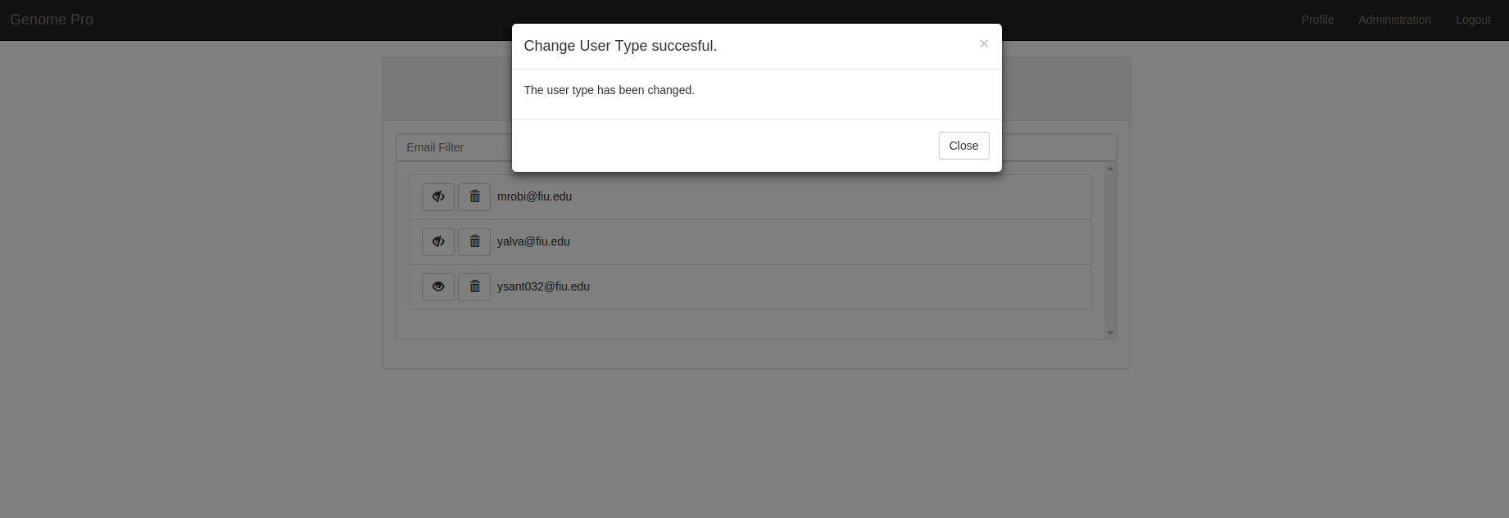

# 

# **References**

<http://users.cis.fiu.edu/~mrobi002/research/research.php>

<http://users.cis.fiu.edu/~mrobi002/biography/biography.php>